<https://drive.google.com/drive/folders/15dfDBwqC-3mMw6luTz11V00SBggDVQPH?usp=sharing>

ChatGPT 5 use-cases <https://youtu.be/Bw7pAYv6iaM?si=Ja4zYZlBDx0cZiPw>

# Q-Learning Intuition

**Reinforcement Learning**  
It’s like training a dog, the agent/robot/dog looks at the state of the environment & rewards, and does actions based on it.  
There’s a difference between pre-programmed vs reinforcement learning based agents/AI  
Reinforcement means no pre-programming, no hard-coded algorithm, just a free-learning thing  
  
**The Bellman Equation**  
The variables:  
 S - State

A - Action  
 R - Reward  
 Y - Discount  
R = 1 is the goal block, R = -1 for the Danger block

And we let the Agent just explore the block maze  
You can guide the AI to reach a specific goal, bit by bit.  
 So with a maze, you can just work backwards  
V - value  
But if you value everything on the path to the goal, as V=1, then the robot wouldn’t know to go forward or back.  
  
The Bellman Equation is

V(s) = max(R(s,a) + YV(s’))  
 You want the maximum reward from the action/state you choose, plus s’(new state) the value of s’  
The Final state doesn’t have value it Only is the Reward in this context  
The Discount Y is used so that the values will slowly get smaller the further away from the reward it is, so the path is clear which direction to go.  
  
**The “Plan”**  
Is different from policy  
The Plan is just the map of Direction to go for each step/ block  
Policy is protocol I guess  
  
**Markov Decision Process**  
Deterministic vs non-deterministic Search  
Non-deterministic search randomizes which direction you go  
While Deterministic search means you have a specific response for every specific situation  
  
*Markov Process and Markov Decision Process (MDP)*  
“A Stochastic process has the Markov Property if the conditional probability distribution of future states of the process (conditional on both past and present states) depend only upon the present state, not on the sequence of events that preceded it. A process with this property is called a Markov Process.”  
Aka  
The Markov Process only cares about where you are right now, not where you were.   
  
“And a Markov decision process or a MDP, or Markov decision processes, provide a mathematical framework for modeling decision making in situations where outcomes are partly random and partly under control of a decision maker.”  
The Markov Decision Process is somewhat randomized  
And the Markov Decision Process is also an Add-on to the Bellman Equation  
 Add some randomness to the Bellman Equation basically  
Instead of YV(s’) you’re finding the EXPECTED value between the different values of each state  
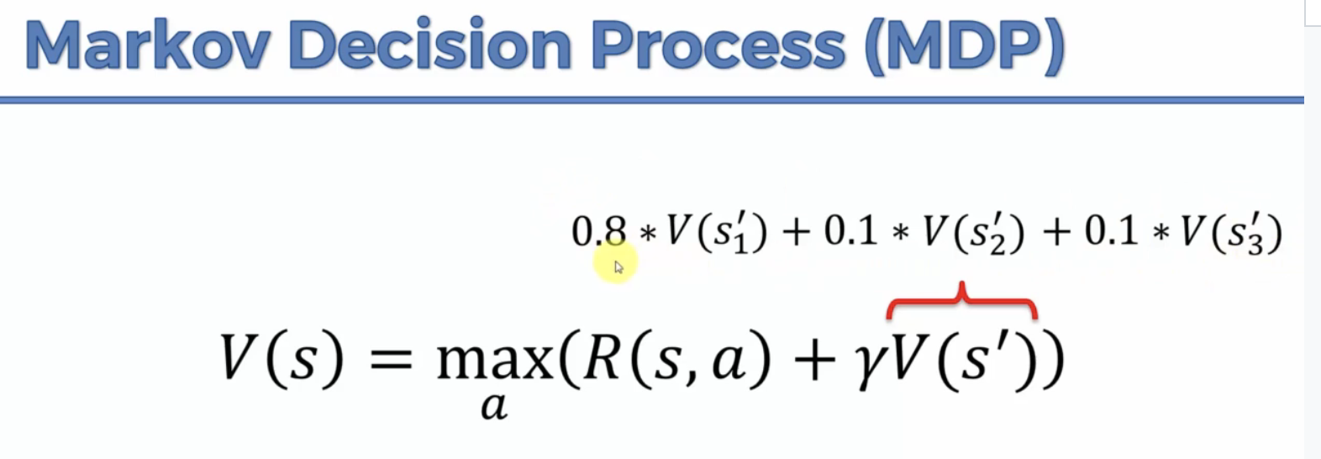  
Or alternatively  
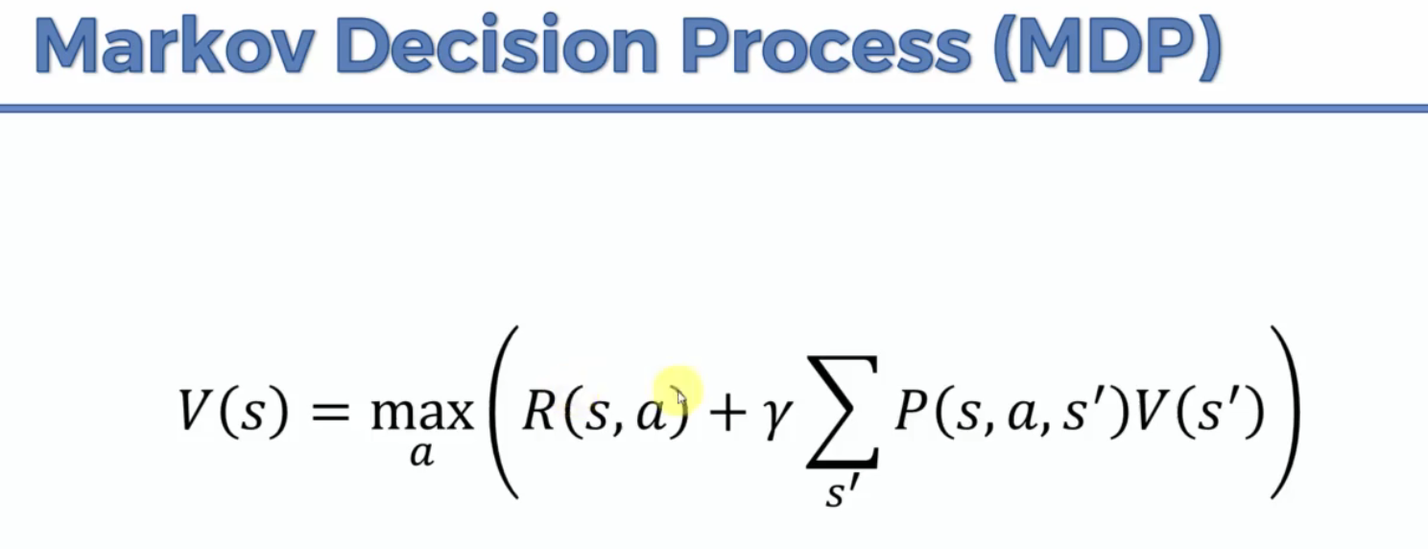  
Now let’s recap what is going on in terms of MDPs. At every time t:

1. The AI observes the current state st.

2. The AI plays the action at.

3. The AI receives reward rt = R(at, st).

4. The AI enters the following state st+1.

**Policy vs Plan**  
Plan means having a contingency case for every single instance because you know every single instance  
But Policy is having a more open-ended response policy for unexpected situations  
 So the value of a state, any S state S is the maximum

across all actions that an agent can possibly perform in that state.

And the maximum was taken from the reward

that the agent will get by perform action A  
 in state S plus a discount factor multiplied

by the expected value of the new state it will be in.

And the expected value is taken here because there are

it doesn't know exactly what state will end up in.

The values of blocks now with RANDOMIZATION  
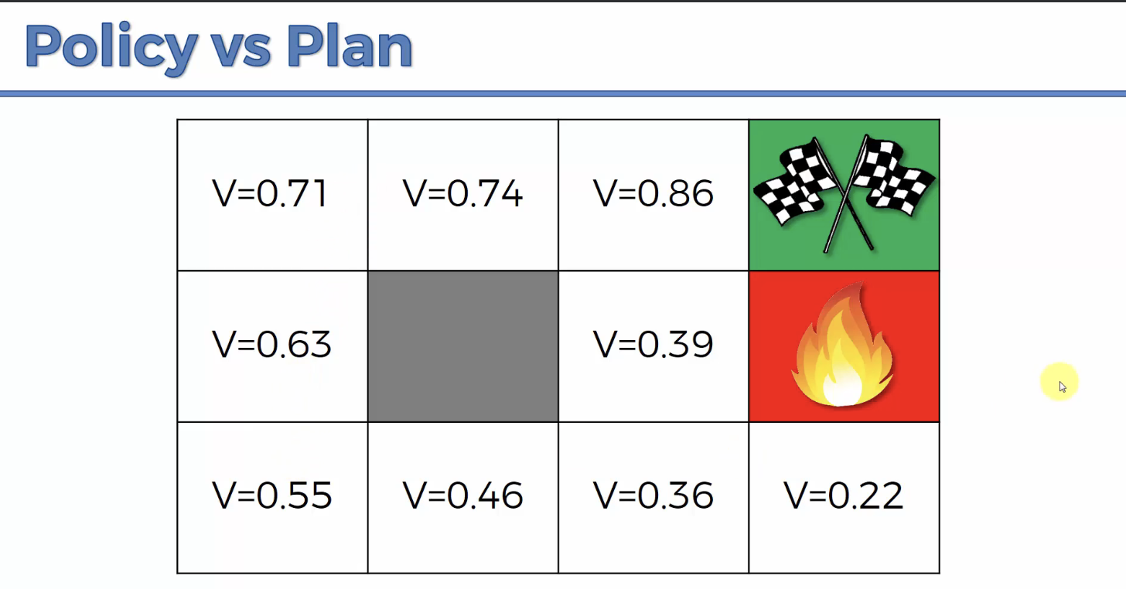

The block right next to the goal is no longer 1, since there’s a chance you might not go right  
The one next to the fire is no longer 0.9 because there’s a chance you might go into the fire and lose the reward which is a big drop in the Expected Value.  
So the flow becomes less deterministically, Shortest path to goal, it becomes more (stay away from the fire, go on the safe path even if it’s farther away)  
  
**Adding a “Living Penalty”**  
You want rewards throughout the journey, not just the very end.  
If you give every block a small negative reward for moving around, it’ll incentivise the AI to get there quicker.  
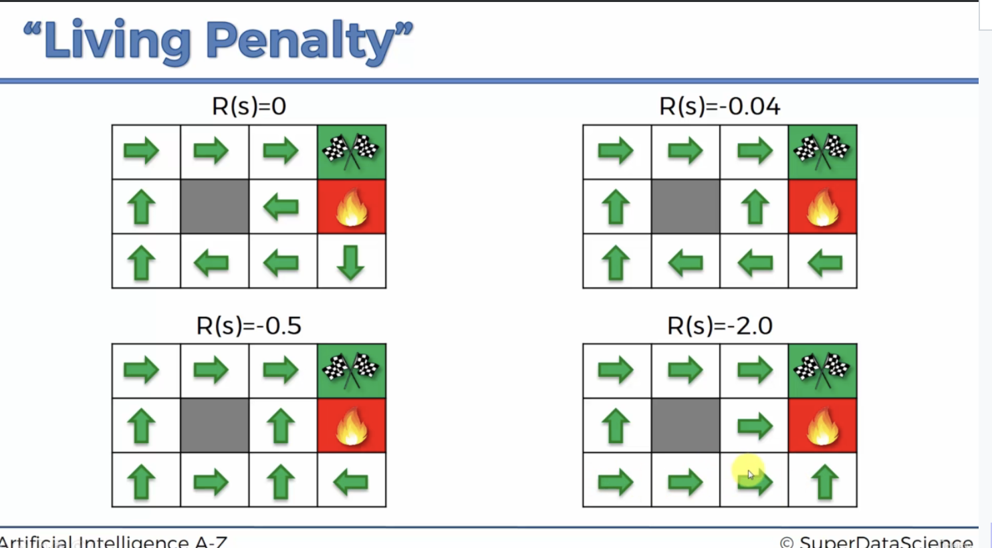  
  
**Q-Learning Intuition**  
Why is it called Q-Learning?  
Well because we move away from Values and instead of Q(s,a)  
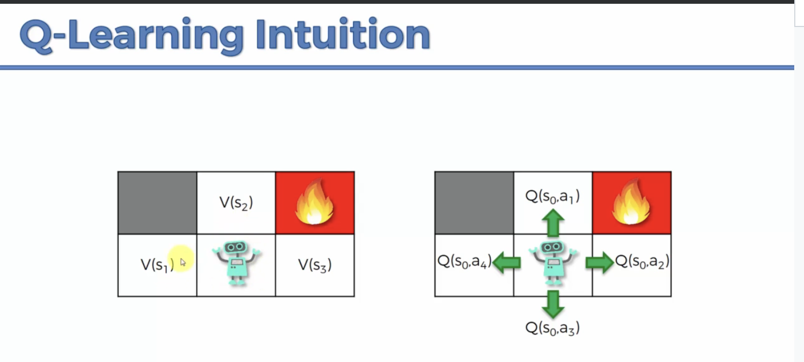  
Rather than looking at the values of each state, you’re gonna look at the values of the ACTION.  
Q might mean - QUALITY instead of value  
Quality of the Action, specifically  
The S represents the state you’re in Before performing the action  
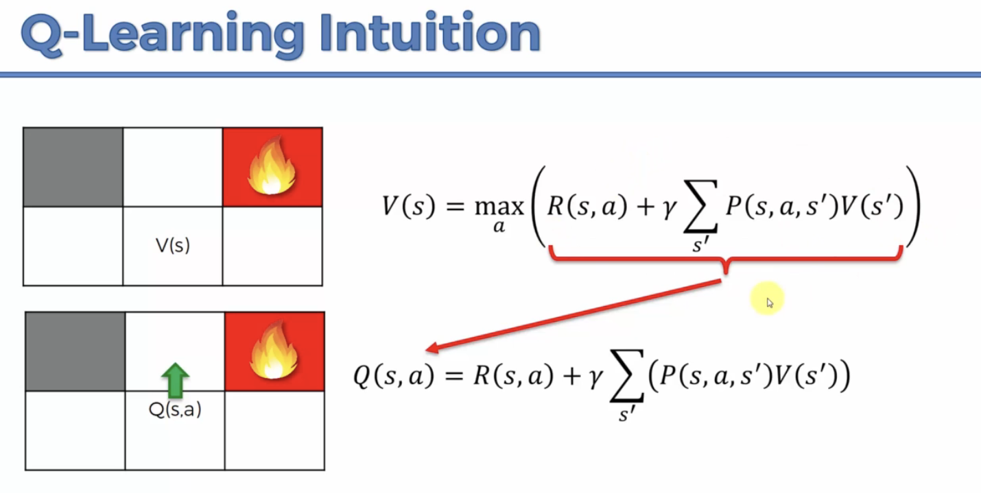  
It’s honestly not that different, you’re just quantifying the expected value ahead of time  
  
But we can rewrite the equation without V  
We can replace V with Q  
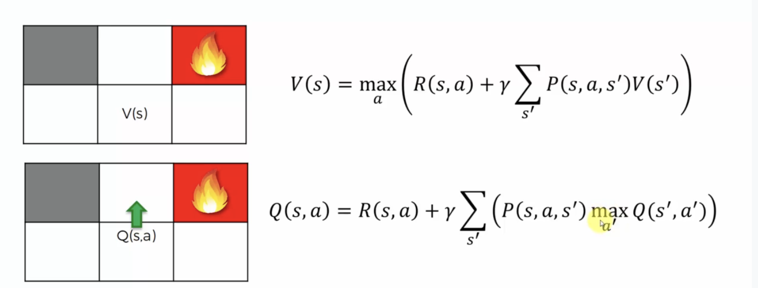  
  
So yeah, Reward plus Discount * Sum of (Probability * Max(Quality of Action))  
  
**Temporal Difference**  
Rewrite the formula just to be easier to write

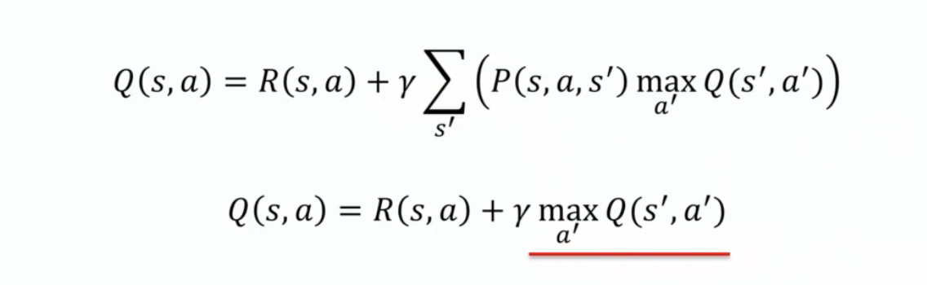

It still should mean the longer formula though  
  
Temporal difference is basically saying there’s a difference between the value before and after the action. Despite it theoretically being the same  
Q(s,a) is the value stored in memory  
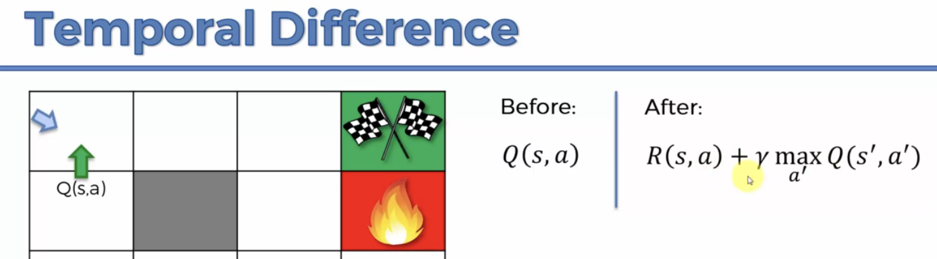  
And afterwards you got the new information on the reward you got  
The Temporal difference formula:  
  
Ideally they should be the same because the formula says they’re equal, however Q(s,a) is not calculated it’s something from measuring.  
It’s the difference between Q(s,a) before and Q(s,a) after  
  
Alpha = the Learning Rate  
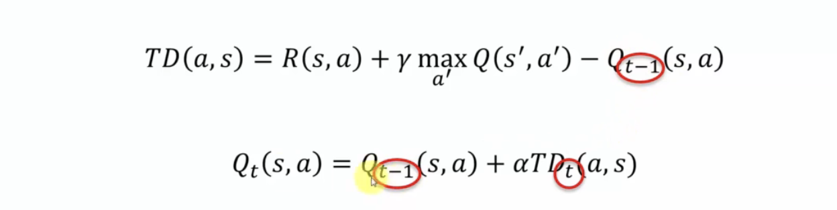  
Behold, the formula with Before and After indicators  
And then you can plug in the long equation into TD (Temporal Difference)  
  
So now you understand that Alpha is pretty important actually

This formula is probably only useful when the environment is continuously changing

# Q-Learning Implementation

Q-Learning isn’t as powerful as Deep Q-Learning so the course only provides a PDF for it’s implementation

# Deep Q-Learning Intuition

Deep Q-Learning is combining Q-Learning with Artificial Neural Networks  
States in the environment are encoded by a vector which is used as an input in the Neural Network, the Neural network makes predictions and returns outputs of Q-values for each action.  
  
**Learning**  
Rather than just math of Q-Learning  
We’re gonna add axis values, and then feed the axis values into the Neural Network  
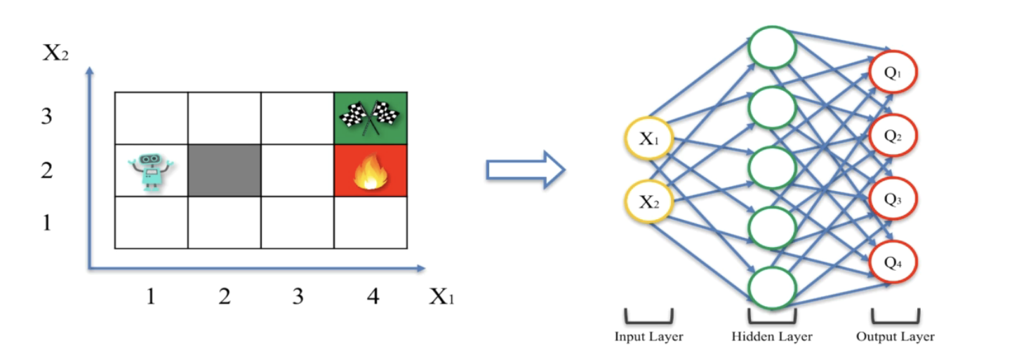

Temporal Difference equation

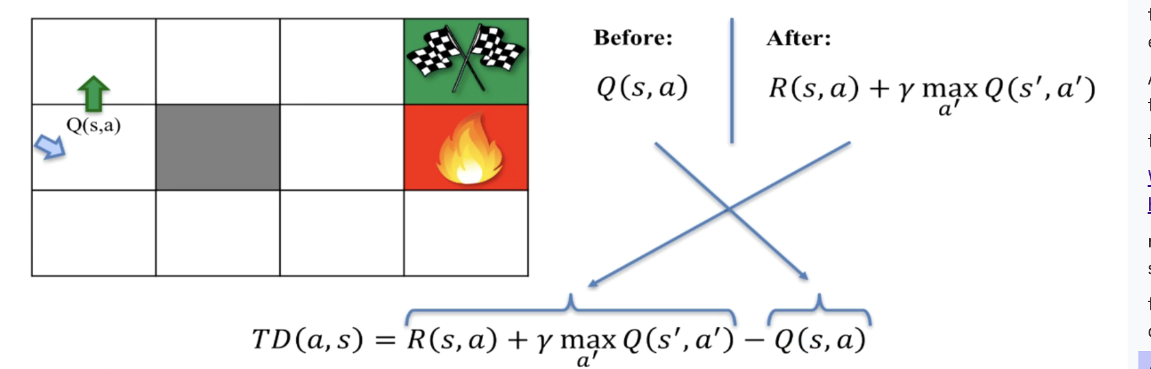

We take what he got after minus what he got, what he had in mind, what he was expecting, you'd subtract one from the other and that's your temporal difference. And then you use your learning rate alpha to adjust your Q value to your new Q value by the temporal difference, but with a coefficient of alpha.

Deep Q-Learning doesn’t do Before and After the same though

They use Predicted value in the past that was stored, and compare it to the predicted value now.

Each Q value has a target to compare to, learn via comparing the difference between them

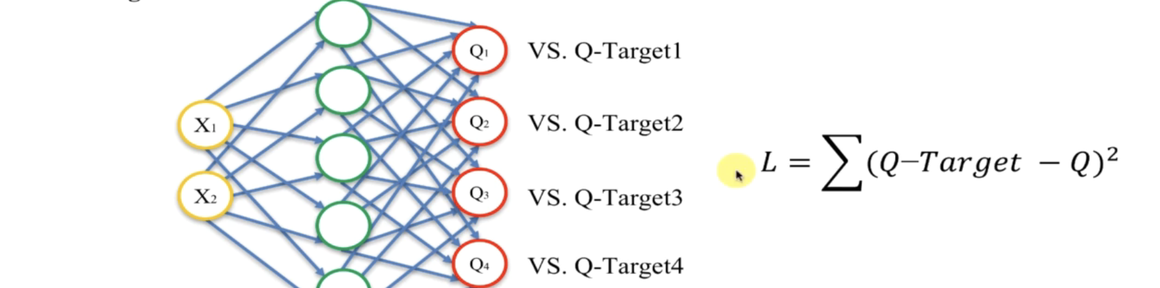

Use Temporal Difference for Backpropagation to adjust the weights bit by bit  
  
**Acting**  
Softmax helps you choose the best Action/Q-value to go with

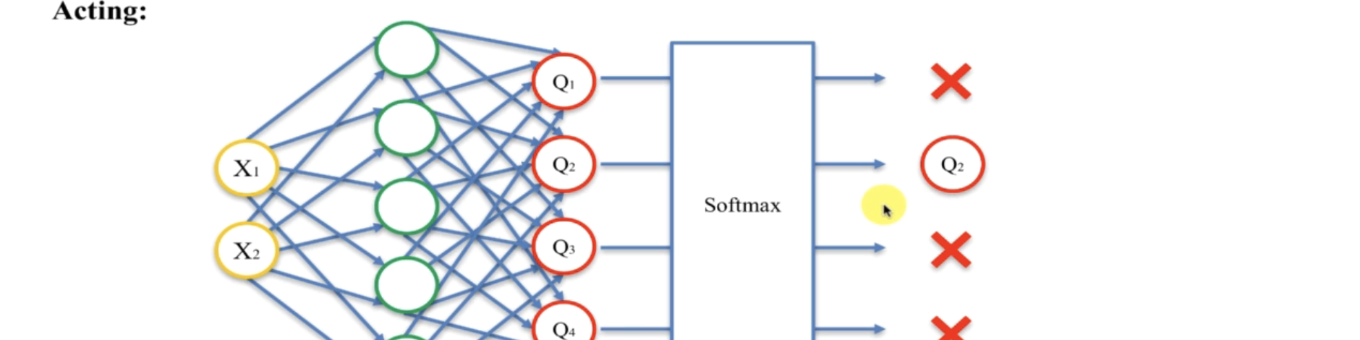

Input represents the state, the axis values for where you are

The Q values represent the actions to take

This cycle of learning and predicting happens each time the agent goes into a new state

In Convolutions, that’s when the agent looks at the whole image instead of the adjacent stuff?

a  
**Experience Replay**  
What happens in Experience Replay is, these experiences, so these states that it's in one, two, three, however many 50 states here in a row, they don't get put through the network right away. They're actually saved into memory of the agent. And so for instance, it saves all these, once it reaches a certain threshold, then the agent decides for itself, "Okay, it's time to learn."

The Agent has to figure out at what point to start doing Batch Learning

Because you might get a big bias if you do Reinforcement learning for every state change

The Sharp corners would mess you up since the bias would be harder to overcome

Normally Batch has a rolling window of experiences, forgetting old stuff.

an experience in Experience Replay, it stays in the batch for quite some time and the car or agent can learn from that experience several times.

Experience Replay gives you an opportunity to learn from more experiences than if you were just learning for one at a time, because you have that batch and therefore, it's a rolling window, and therefore, even if your environment is limited to experience, your Experience Replay approach can help you learn faster. And instead of just redoing their environment, many many times, you can learn faster because you don't have to redo it.

a  
**Action Selection Policies**  
Softmax just means picking the Q with the highest value, pick the Highest action

Why wouldn’t you take the best Q value?

There are other Action Selections other than Softmax

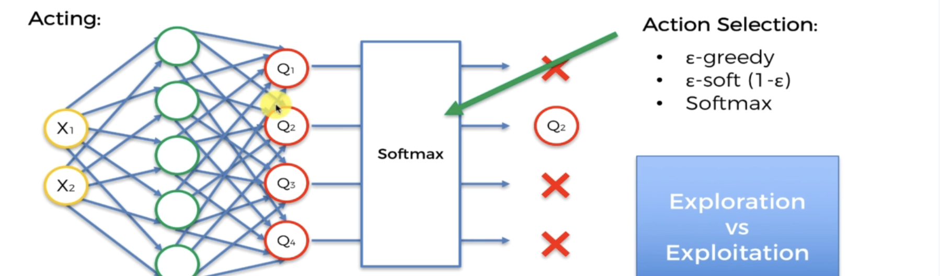

There’s a difference in motive, Exploration vs Exploitation

You want to have exploration to give the NN the ability to unstuck itself from a local Maximum

Maybe something that looks good leads you into a path with a worse situation, or that you’re missing out on a better path.

Exploitation - picking the better options

Exploration - checking out other options so find better ones if the best one is actually not great

Epsilon-Greedy Action Selection means to select the Q with the best Value except for (epsilon)% of the time, so you randomize a chance to not pick the best value.

Softmax has to do with Convolution Neural Networks

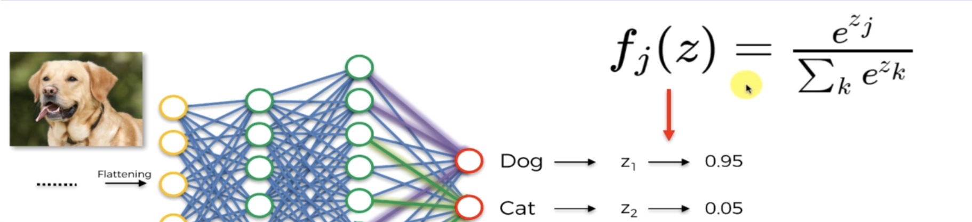

This is a convolution Neural Network that claims 95% chance it’s a dog  
And the Formula fj(z) is the softmax equation

Softmax isn’t just picking the highest value, it’s just showing the probability that the action is best

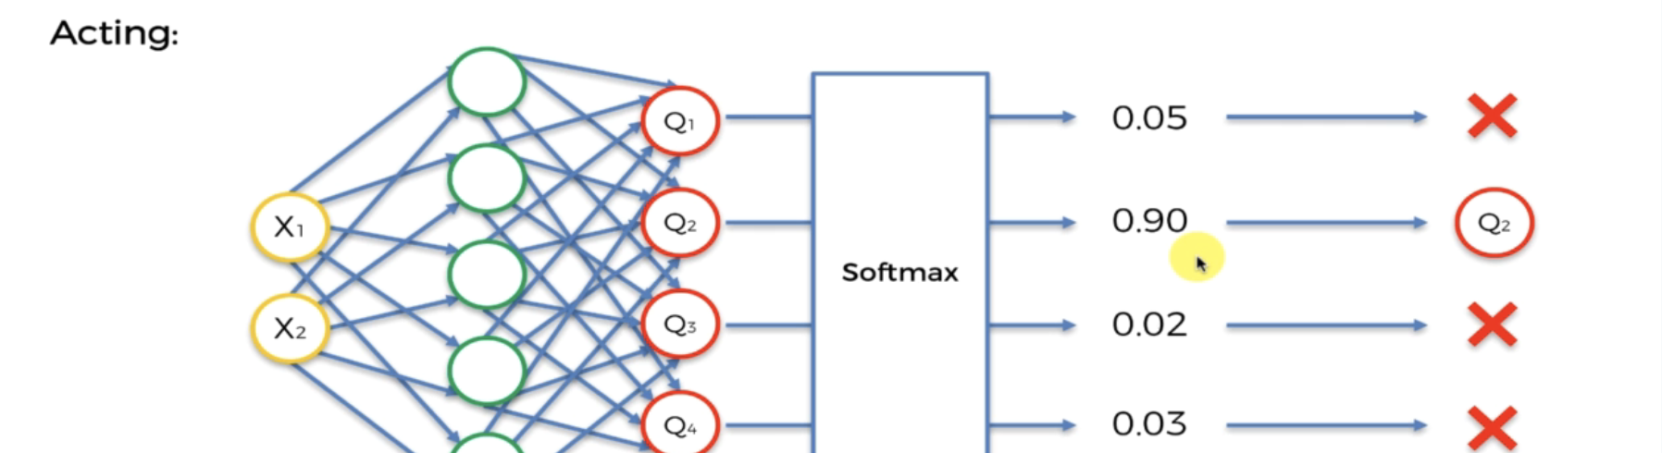

So normally you use those probabilities as how often to go with that action

The probability might chance over time as the Neural Network learns and explores the place

# Deep Q-Learning Implementation

You can find all the codes in the link below. The codes are implemented on Google Colab notebooks, so please make sure to have a Gmail address because you will need a Google Drive to work on the Colab notebooks:

<https://drive.google.com/drive/folders/15dfDBwqC-3mMw6luTz11V00SBggDVQPH?usp=sharing>

My copy <https://colab.research.google.com/drive/1XvENNVo5j0CWxoqe2wSluJxfBq-jHdZF#scrollTo=Vm1hAkgr3_Ye>

Now to implement it on chatGPT

I just use google robzheng3 for OpenAI

Everybody can use ChatGPT to build a Deep Q-Learning model

but very few people can implement a Deep Q-Learning model

Jjj

# Deep Convolutional Q-Learning Intuition

Advanced version of Deep Q-Learning

Getting vectors as input is kinda cheating since normally robots wouldn’t be getting coordinates

If we want to recreate humans, then the input will be more realistic and just be vision

Instead of coordinates you get a Convolutional layer and Pooling layer

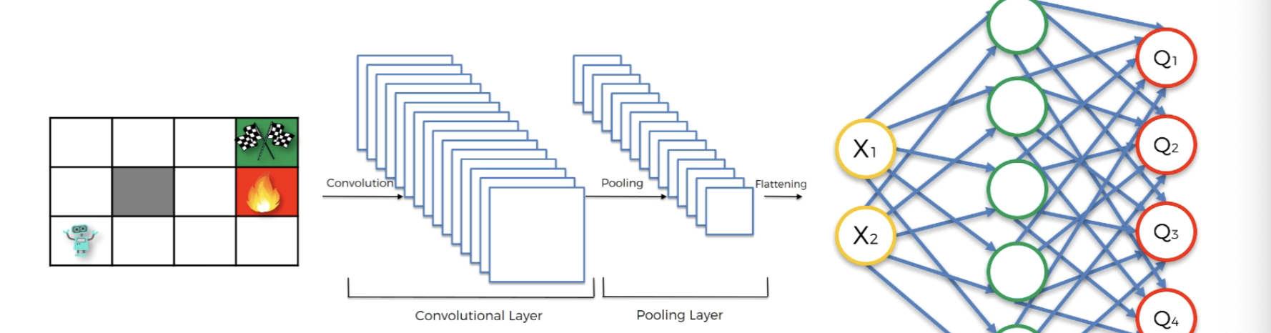

So imagine the maze as an IMAGE of the environment while the agent is looking within the environment.

Kinda like Doom, rather than coordinates you get a first person view.

The Agent gets a picture of the Doom POV first person, every pixel  
  
**Eligibility Trace (N-Step Q-Learning)**  
An Example:

Normally you have an agent update it’s status and the environment reward information every time it takes an action, every time it takes a step.

But with N-step Q-learning, you only update every 4 or 5, an N number of steps.

First you calculate the TOTAL reward from those 4/5/ etc steps, then put it through the Neural Network. You get a bigger picture view when you only update the neural network with this delay. Because you get to be driven by long-term reward rather than short term reward.

You see the Cumulative reward and Loss of a bigger range of action.

It’s called eligibility Trace because, you know certain steps are Eligible for reward/punishment

Jjj

# Deep Convolutional Q-Learning Implementation

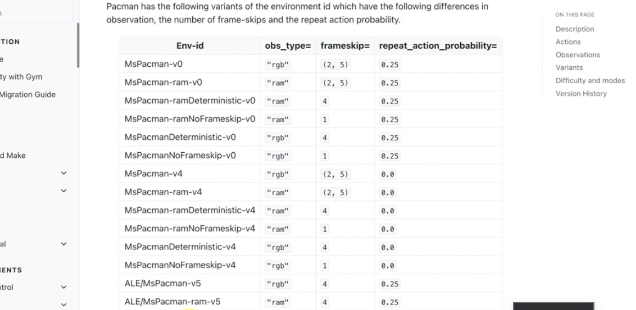  
There are more variants

Deep Convolution can solve some of these, A3C can solve others

Sometimes the title Deterministic doesn’t meant fully deterministic and only partially deterministic

Test copies <https://drive.google.com/drive/folders/15dfDBwqC-3mMw6luTz11V00SBggDVQPH?usp=sharing>

My copy <https://colab.research.google.com/drive/1fsp5_mX2VYwts0-3Fewhr2urEhJH4JoJ?usp=sharing>

# A3C Intuition

Now that we built an AI that has a brain (Deep Q-Learning) and that can see (Deep Convolutional Q-Learning), we will add to it a critic sense (A3C). This model is fascinating because it is taking us closer to the human brain  
 **The three A’s in A3C**

Asynchronous, Advantage, Actor-Critic

<https://arxiv.org/pdf/1602.01783.pdf>

**Actor-Critic**

With deep-convolutional Q-learning, you have convolutional layer, a pooling layer, then flattening into Q-learning neural networks.  
But with Actor Critic you’ll have two sets of outputs

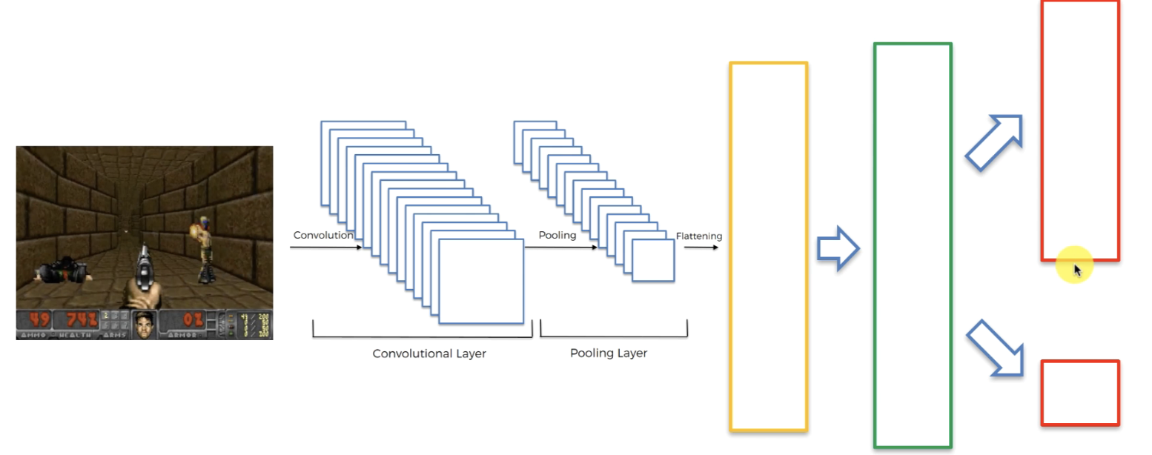

Top set is the set of actions( Q values), and the bottom set is value of the state

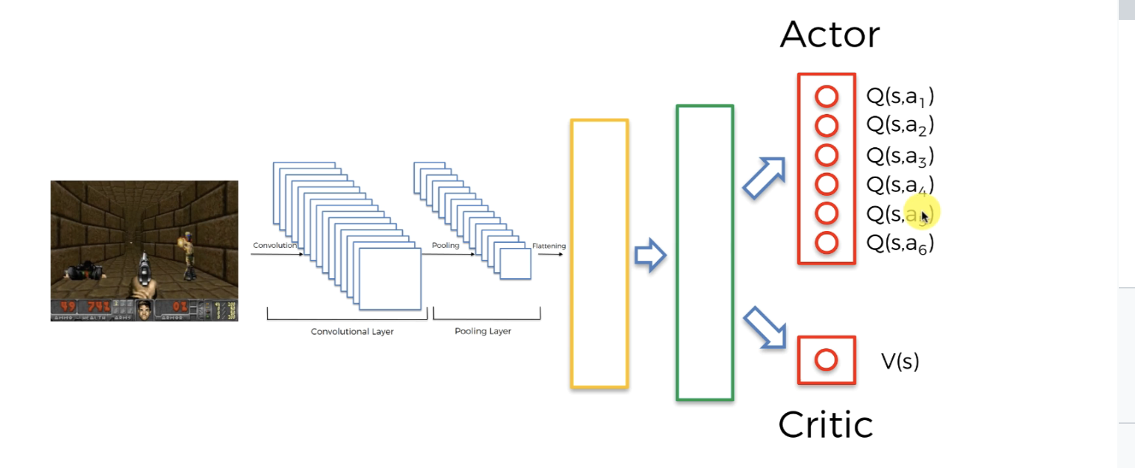

Q values are also called Policy, policy is referred to by a greek letter P

Q values are the probability of taking each potential action

**Asynchronous**

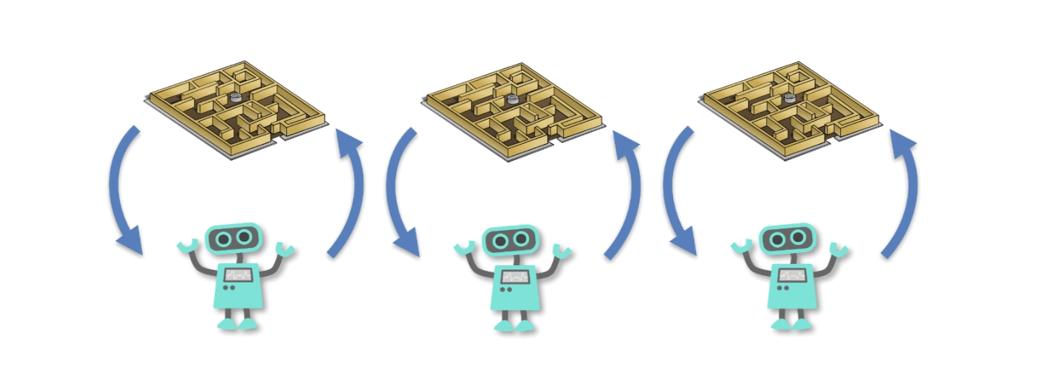

Multiple at once is called Async because they’re INITIALIZED DIFFERENTLY, in the same environment. Different starting point, different SEED.

This helps them find better solutions if one gets Stuck in a local maximum

More agents , more probability of finding a rarer better answer

Three independent Agents…

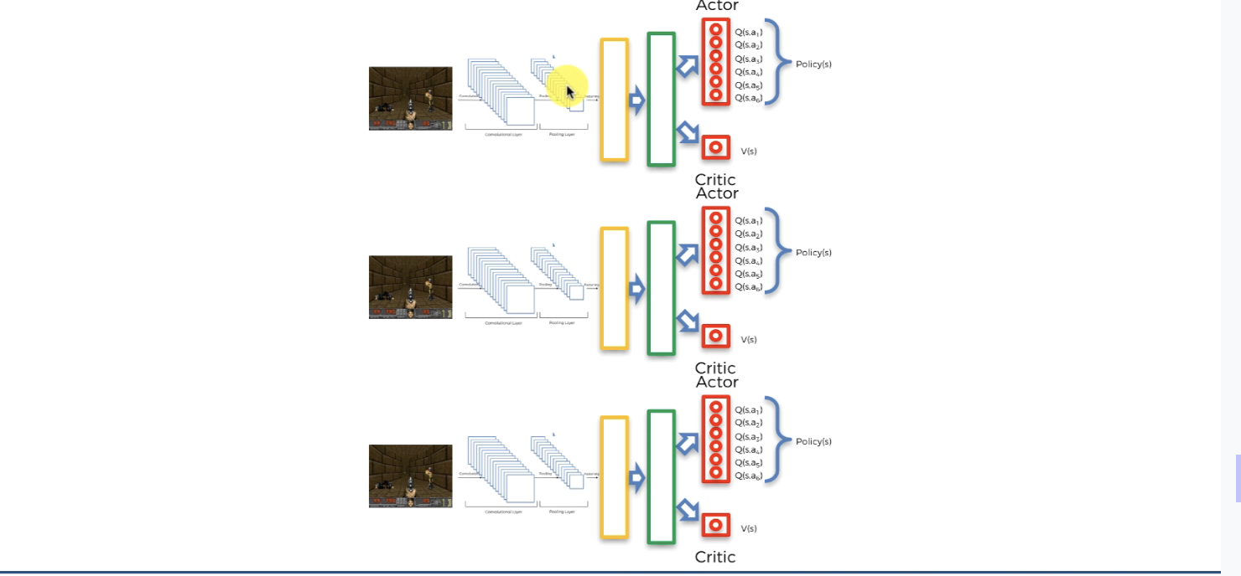

UNTIL THEY BEGIN SHARING INSIGHTS!

They share insights to work Together using the V value in the Critic Section!

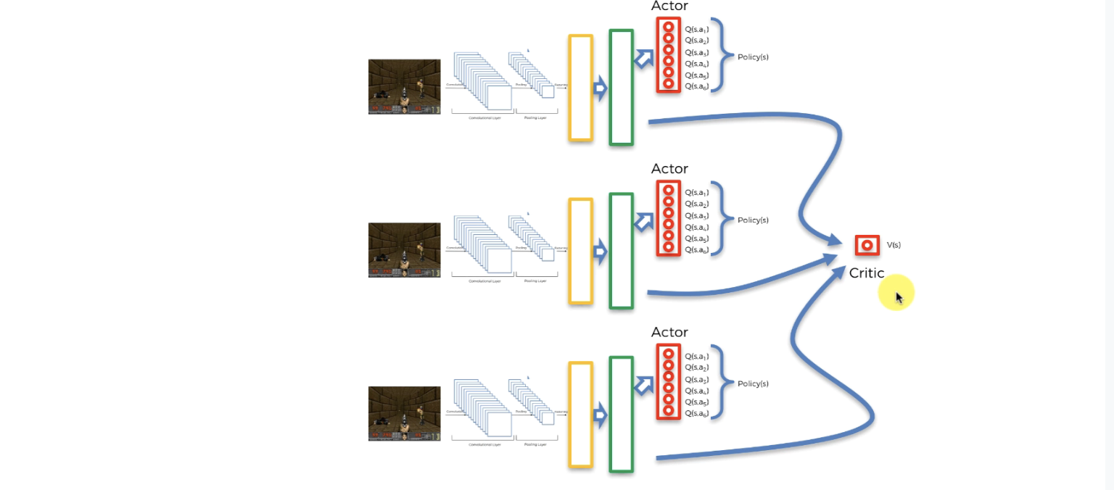

But you can also Compile the flattening process into one 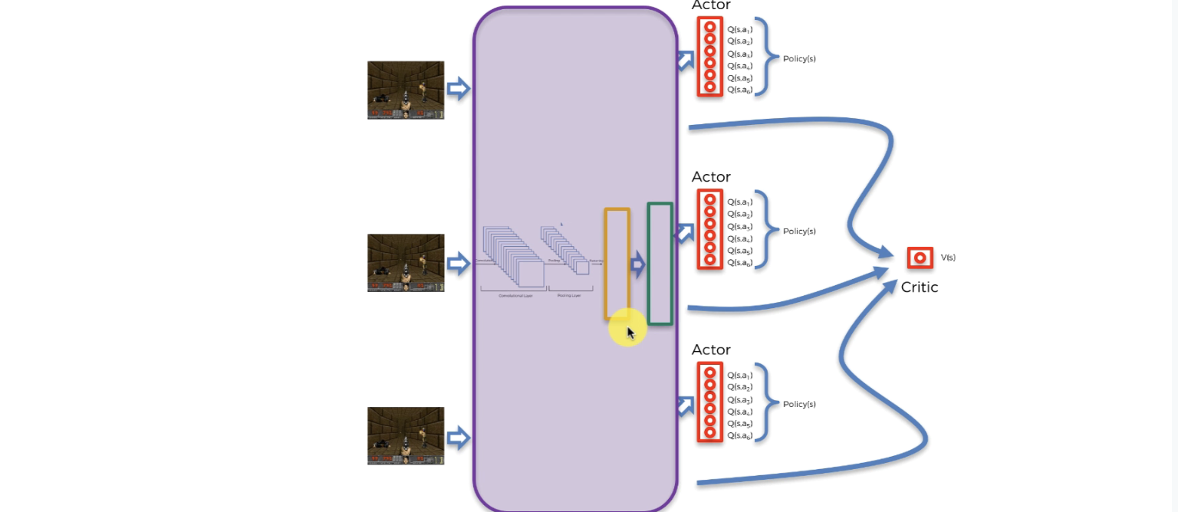

You SHARE the weights of the Network between getting the different actor Critic values.

**Advantage**

Three images as the input go through the same neural network environment and give it’s own outputs

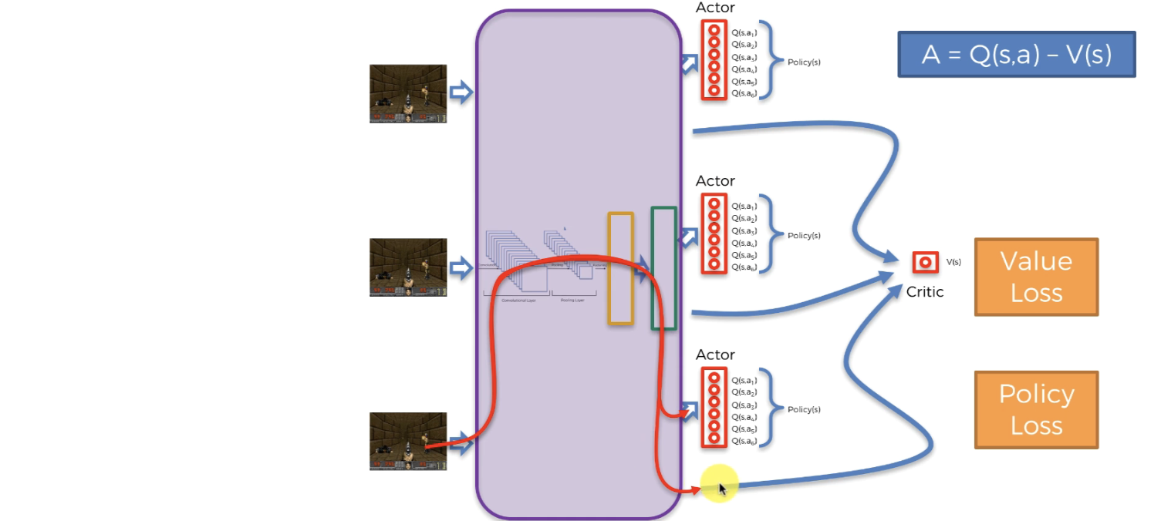

Value Loss: Rewards & Discount factor stuff on trying to get a specific value in the end

Policy Loss: related to ADVANTAGE (Q value minus V value), The V part (critic part) is the shared part, which tells us the overall group value known. What is the advantage of sharing this information? Advantage is used to calculate Policy Loss which backpropagates like Value Loss to change the weight values.

All 3 are contributing to the Critic who overlooks the three processes

The critic critisizes the decisions made by the 3 processes based on the value loss , if the probability leads to low advantage, that’s considered policy loss and they change the weights to make it less likely to happen.

**LSTM Layer**

Long Short-Term Memory

Another way to Modify A3C algorithm is the LSTM which will allow the algorithm to have memory by adding this layer

The Green Box can be turned into the LSTM layer since it’s basically a powerful Hidden layer

LSTM lets you have memory i previous runs

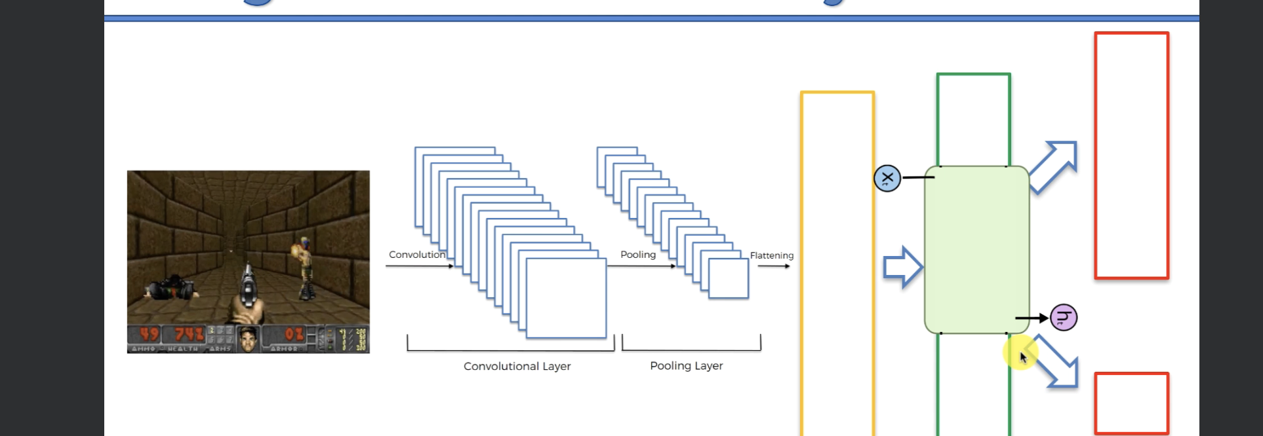

X is a vector layer, a layer being input

H is the output layer, a vector of values being output

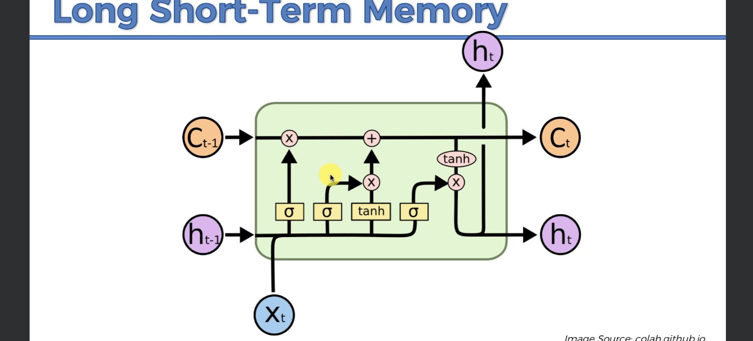

A lot to go on here.

LSTM has more inputs than most hidden layers

Ct-1 and ht-1 are the memory of the past that gets passed as extra inputs

A3C without memory would have a hard time puzzling the Breakout game because one image can’t show what direction it’s going, but if you had memory of where it was before you can figure out where it’s going.

# A3C Implementation

Jjj

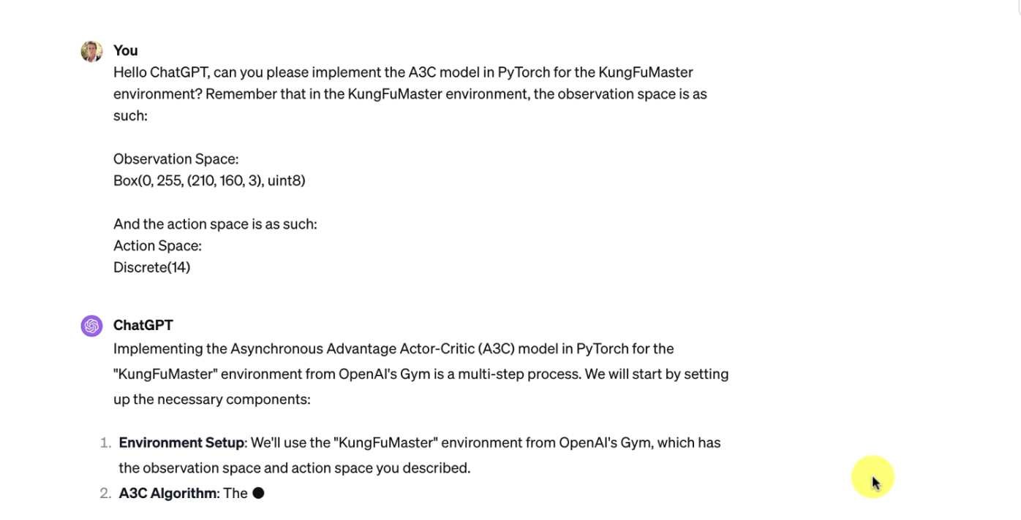

# Intro to Large Language Models LLMs

# Ingredients of a Large Language Model:

Lots of data + Transformer Architecture + Pre-Training(assistance to train the model) + Reinforcement Learning from Human feedback + Fine-tune on Domain specific data

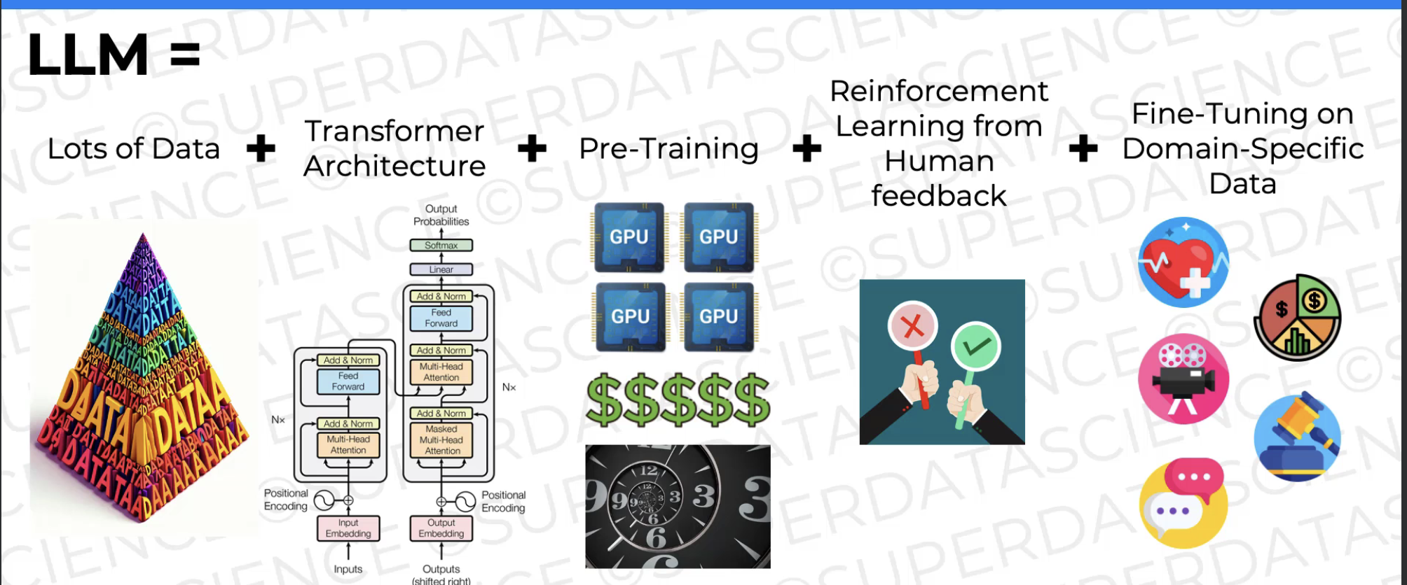

Who Invented Large Language Models?

A Group of Google Researchers

Two parts to the architecture: encoder and decoder, if you throw out the encoder part you can make some language generation used in chatGPT

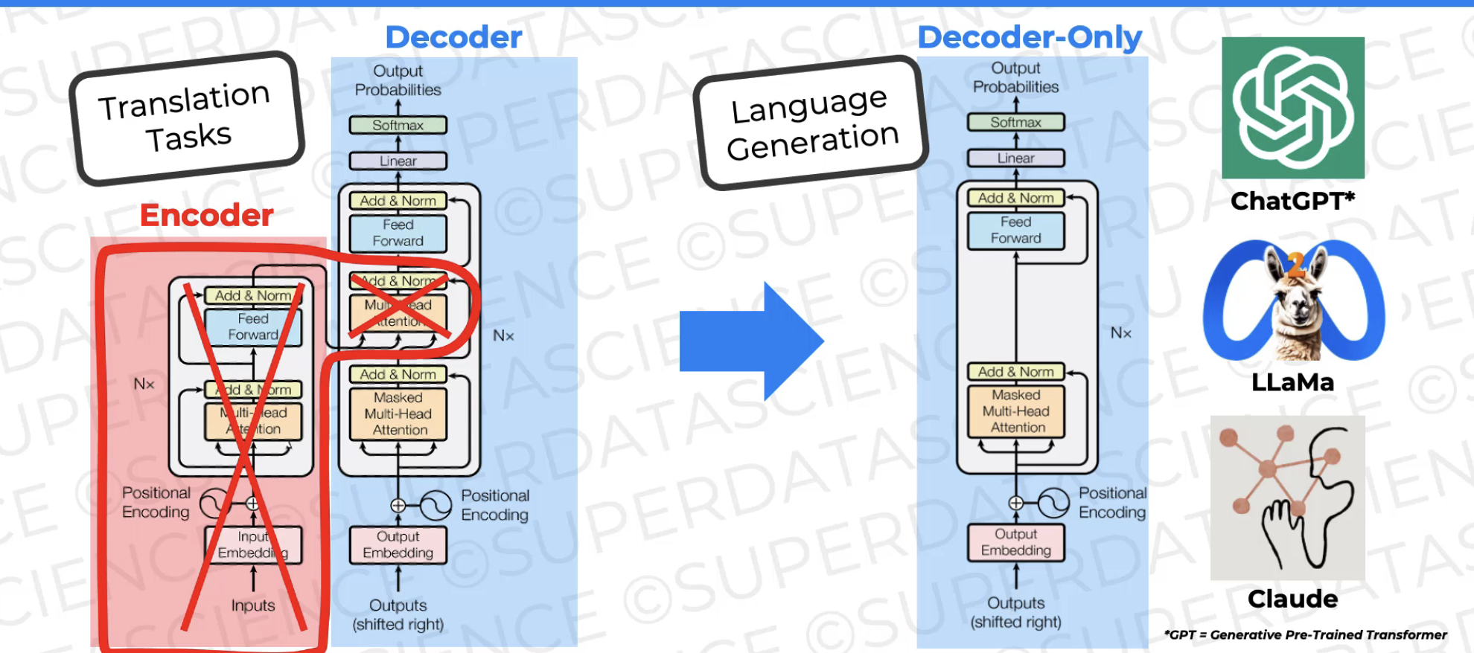

ChatGPT predicts the response one word at a time until end of sequence token 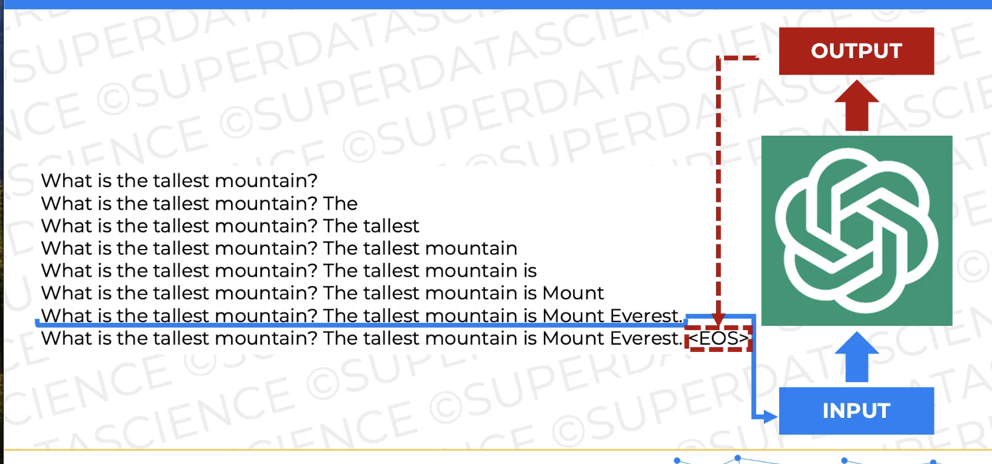

“Output Embedding” is for converting words into Vectors

Positional Encoding helps position what order the words should be

Add& Norm + Masked Multi-Head Attention, is for capturing Contextual Information, context changes what “it” refers to

Feed Forward is for Increasing learning capacity, it’s just neural layers for deep learning

Softmax and Linear is for outputting the result, putting all words in the english language and give them a probability value.

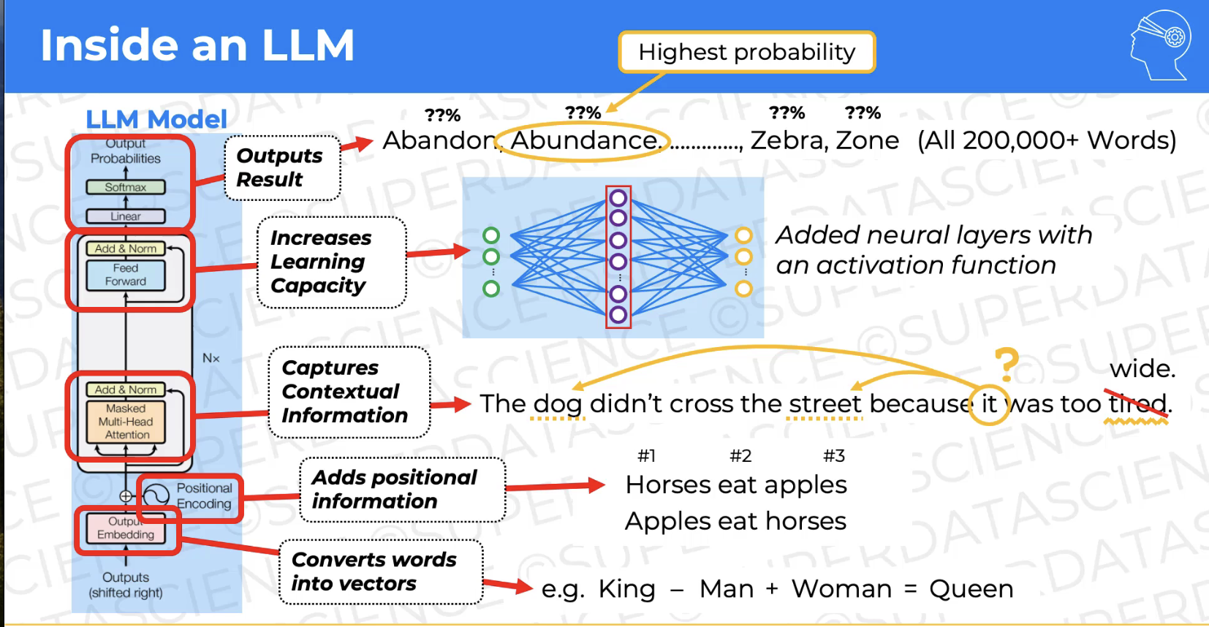

Large Language Models have so many parameters

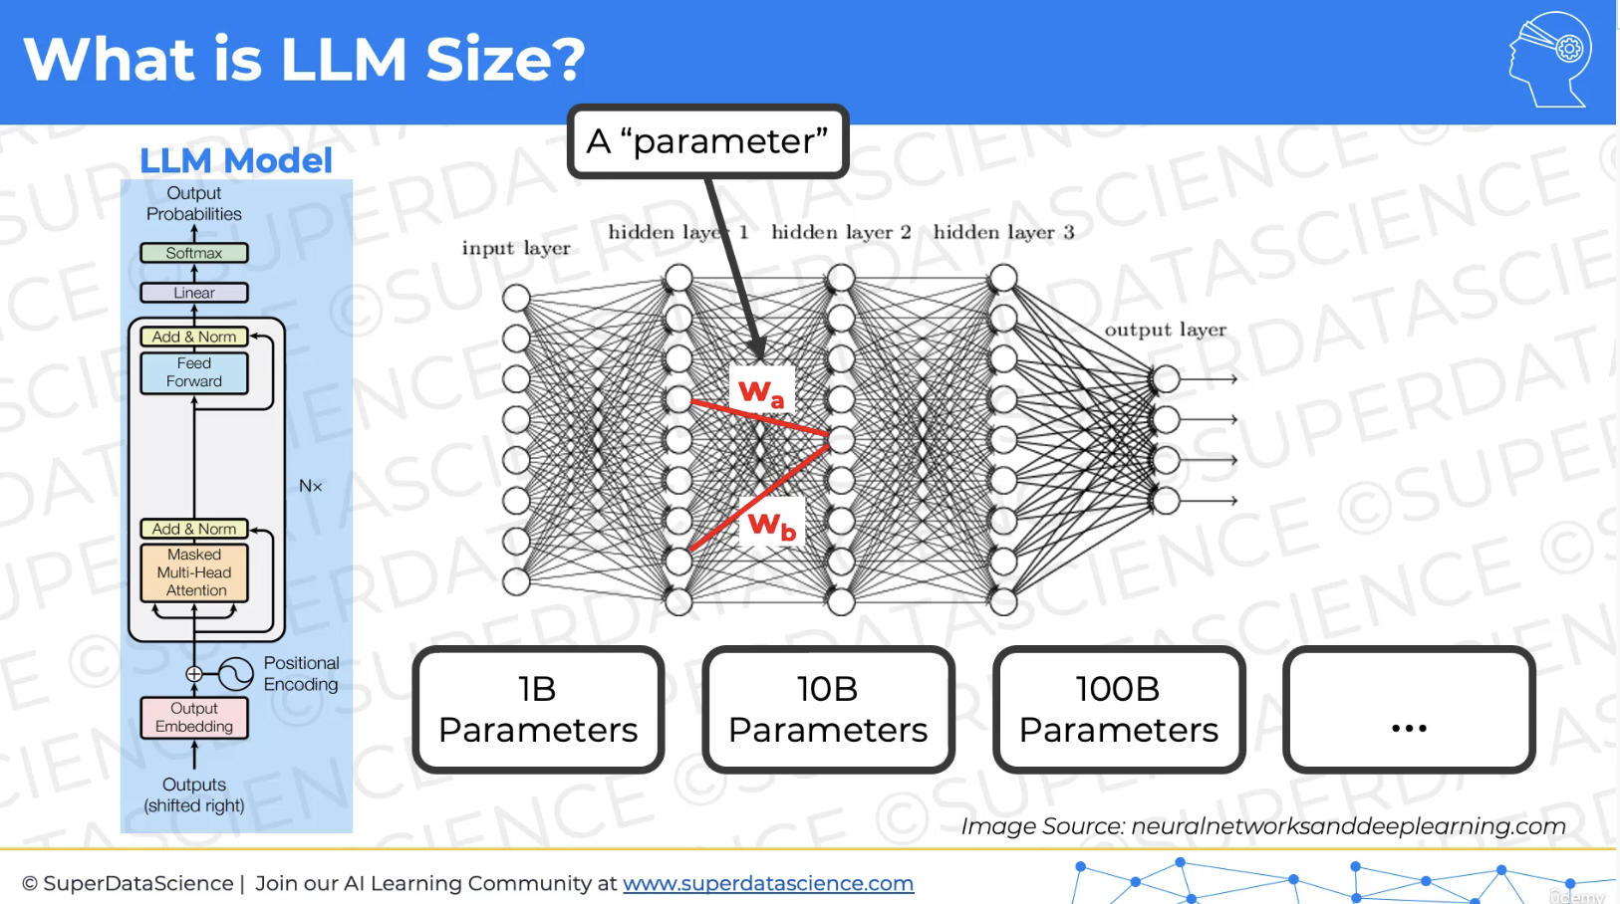

One billion parameters means one billion Weights/connections

LLM Context Window refers to the LLM remembering the context of the conversation, but it only remembers the most recent part of the conversation, it forgets quickly.

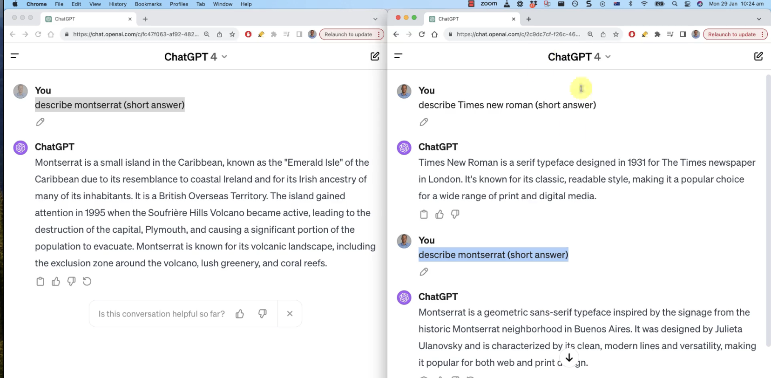

LLM Fine-tuning time!, for specialization  
You put it through specialized data

h

# LLM Implementation

<https://drive.google.com/drive/folders/12bRCt78Kt6wRd3MEgkJco6PjxCmNMANN>

Also, please find below all the links to the Hugging Face tools we will use in this implementation:

1. [The source dataset](https://huggingface.co/datasets/gamino/wiki_medical_terms)
2. [The formatted dataset](https://huggingface.co/datasets/aboonaji/wiki_medical_terms_llam2_format)
3. [The pre-trained Llama 2 model](https://huggingface.co/aboonaji/llama2finetune-v2)
4. [The from_pretrained method from the AutoModelForCausalLM class](https://huggingface.co/docs/transformers/model_doc/auto#transformers.AutoModelForCausalLM.from_pretrained)
5. [The BitsAndBytesConfig class from the transformers library](https://huggingface.co/docs/transformers/main_classes/quantization#transformers.BitsAndBytesConfig)
6. [The from_pretrained method from the AutoTokenizer class](https://huggingface.co/docs/transformers/model_doc/auto#transformers.AutoTokenizer.from_pretrained)
7. [The TrainingArguments class from the transformers library](https://huggingface.co/docs/transformers/main_classes/trainer#transformers.TrainingArguments)
8. [The SFTTrainer class from the trl library](https://huggingface.co/docs/trl/sft_trainer#trl.SFTTrainer)
9. [The LoraConfig class from the peft library](https://huggingface.co/docs/peft/v0.7.1/en/package_reference/lora#peft.LoraConfig)
10. [The pipeline function from the transformers library](https://huggingface.co/docs/transformers/main/en/quicktour#pipeline)

# Jjj

# Artificial Neural Networks

Jjj  
**What is Deep Learning?**  
Neural Networks were invented a long time ago but weren’t relevant until the hardware upgraded to catch up to it. You need both a lot of data storage and data processing for Neural Networks/ Deep Learning.  
  
Deep Learning is a lot of mimicking the human brain  
Information comes in, the info is put through layers of neurons/network nodes and come to a conclusion.  
Deep Learning specifically has multiple layers like a human  
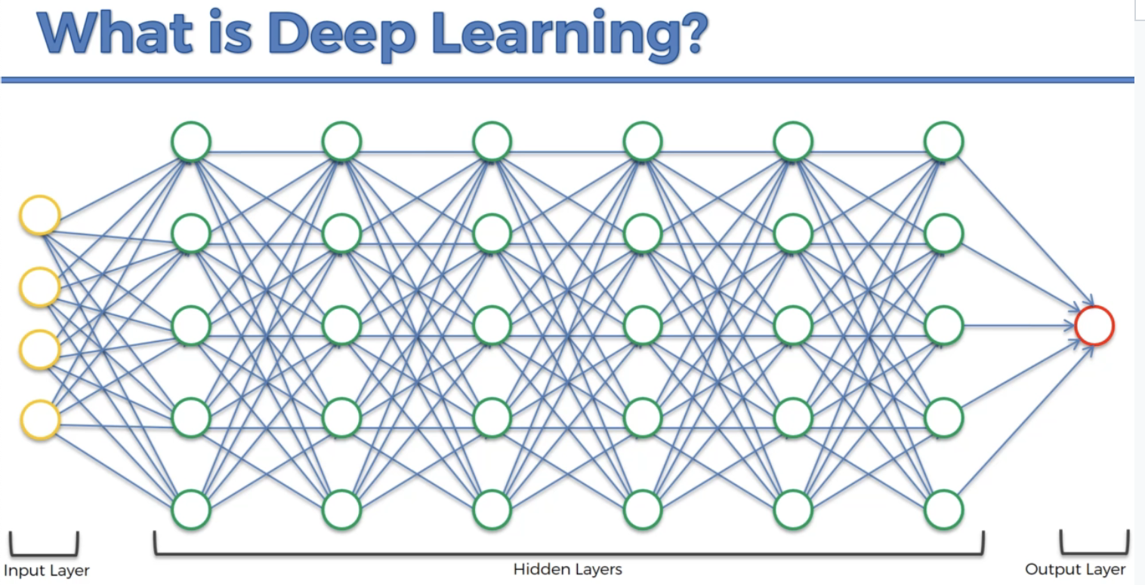  
   
**The Neuron**  
Recreating a neuron for the sake of a Neural Network  
  
Branches are Dendrites, they receive signals  
Axons transmit the signals  
Synapse is the “connection” between neurons  
  
Each neuron is like a hidden layer, taking in inputs and giving outputs  
The input values are all independent variables that are STANDARDIZED and just one row of info, one observation, one Time.  
  
A Neural Network is like a multi-variable Linear Regression

Input values get their own weights, Weights are the thing that get adjusted as the Neuron learns

**The Activation Function**  
4 types of Activation function:

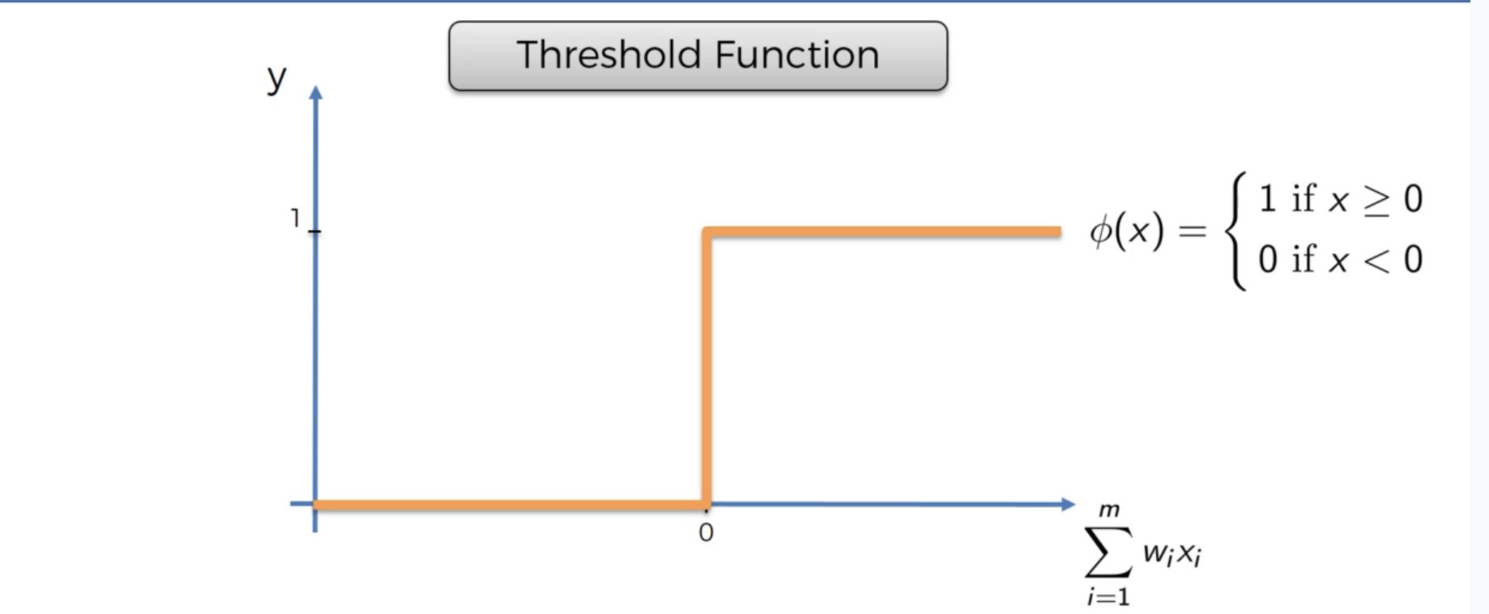

Threshold Function, it’s yes or no depending on threshold

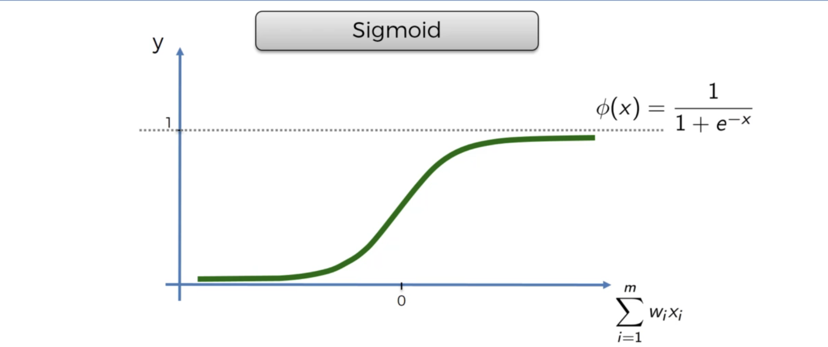

Sigmoid function, is the one used in Logistic regression

Very useful for output layer

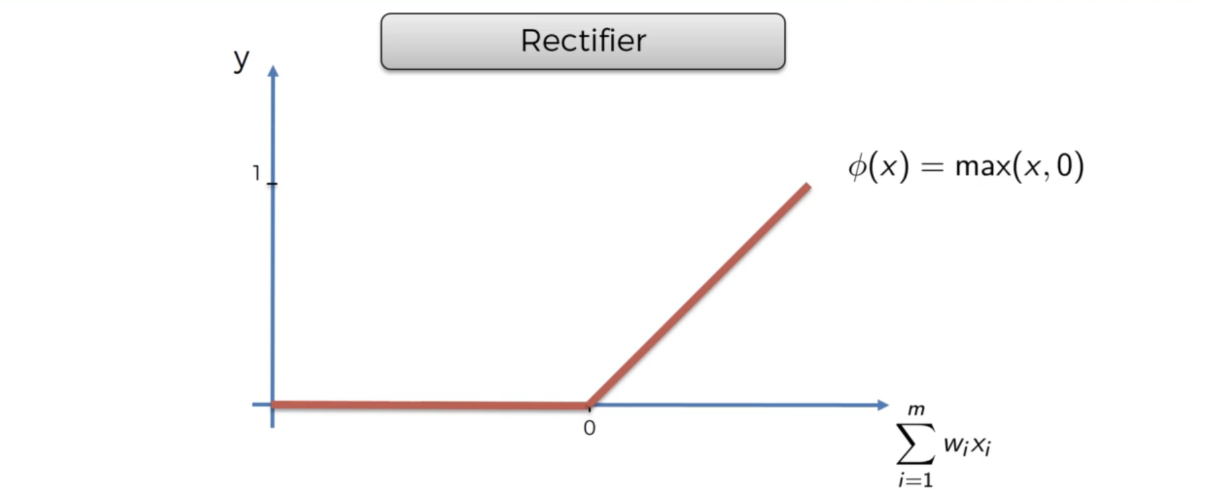  
Rectifier function is most popular for neural networks

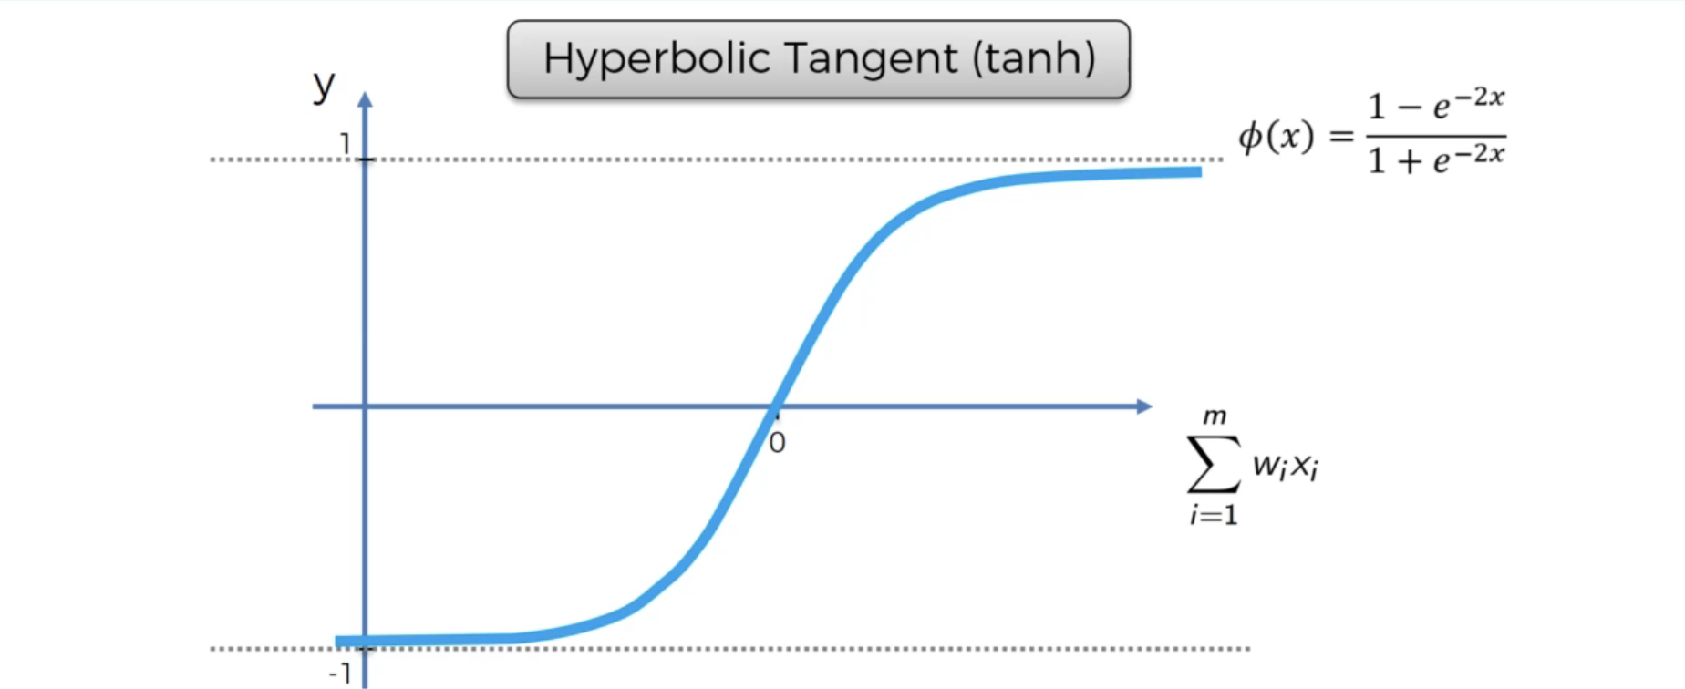

Hyperbolic Tangent is like Sigmoid but it also goes below 0

When the Output value is binary in just one neuron (y= 0 or 1, you should use Threshold activation or Sigmoid Activation)   
But when you’ve got multiple Neurons, you probably use a rectifier function instead  
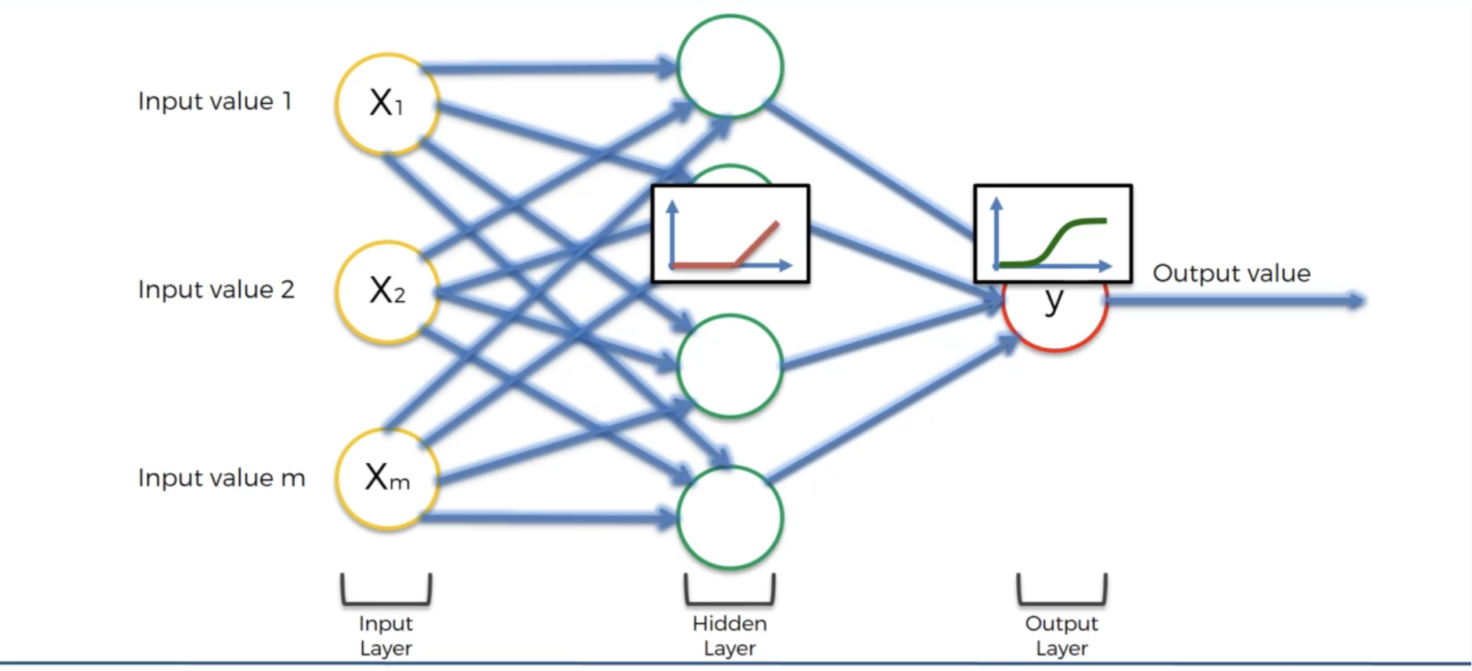  
**How do Neural Networks work?**  
Example of using a NN without training it first

Use a Neural Network to predict property values  
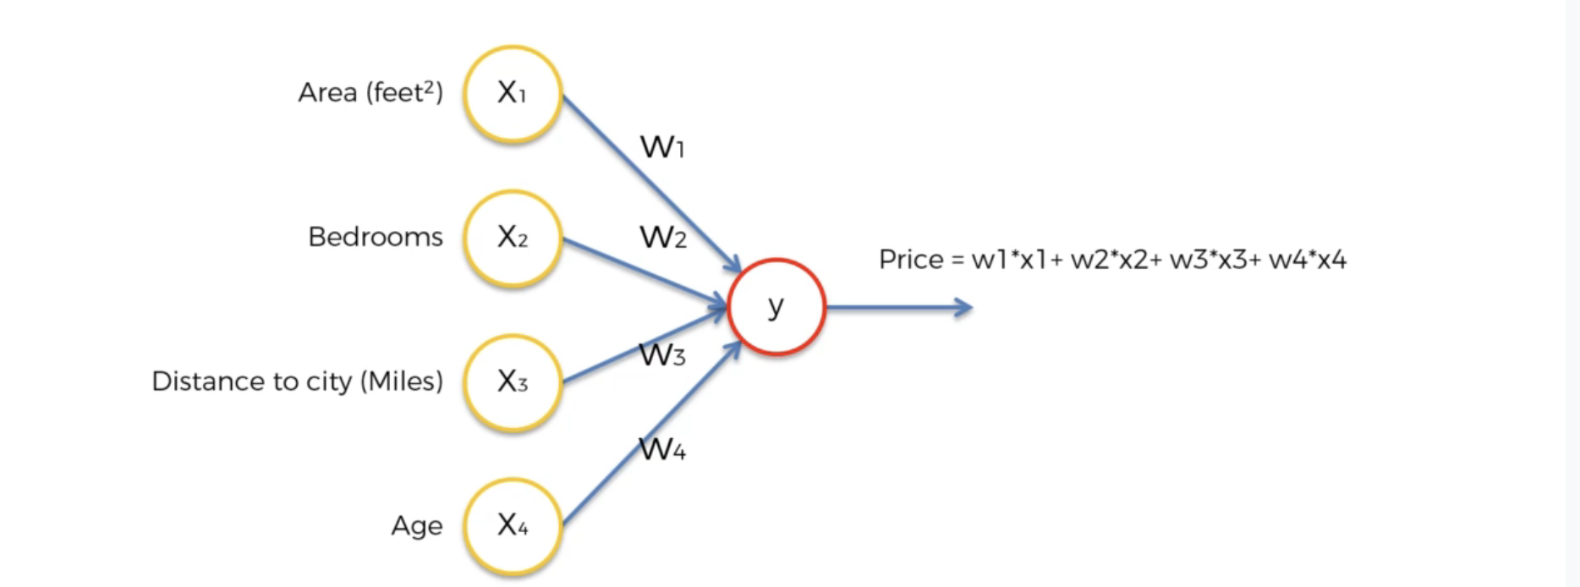

We use the hidden layer in order to help teach the Neural Network

Some weights will be 0, because some circumstances will lead to some factors not important

Like for example, you might have Distance to city might affect the area threshold

Each neuron can take specific sets of factors to represent a different more nuanced factor

Some neurons in the hidden layer could just be One factor being renamed, Age -> historic value so the age being high becomes something good.

Every combination of neuron might pick up factors that you haven’t considered before.

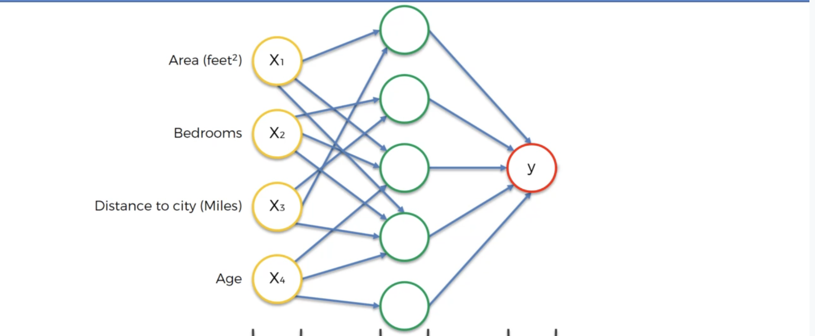

a  
**How do Neural Networks Learn?**  
Neural Network learns from inputs, and figures things out on it’s own rather than having hardcoded values

The Neural Network takes in Inputs, gets an output, and compares it to the Actual Output

In the comparison, you use a cost function to figure out the amount of error

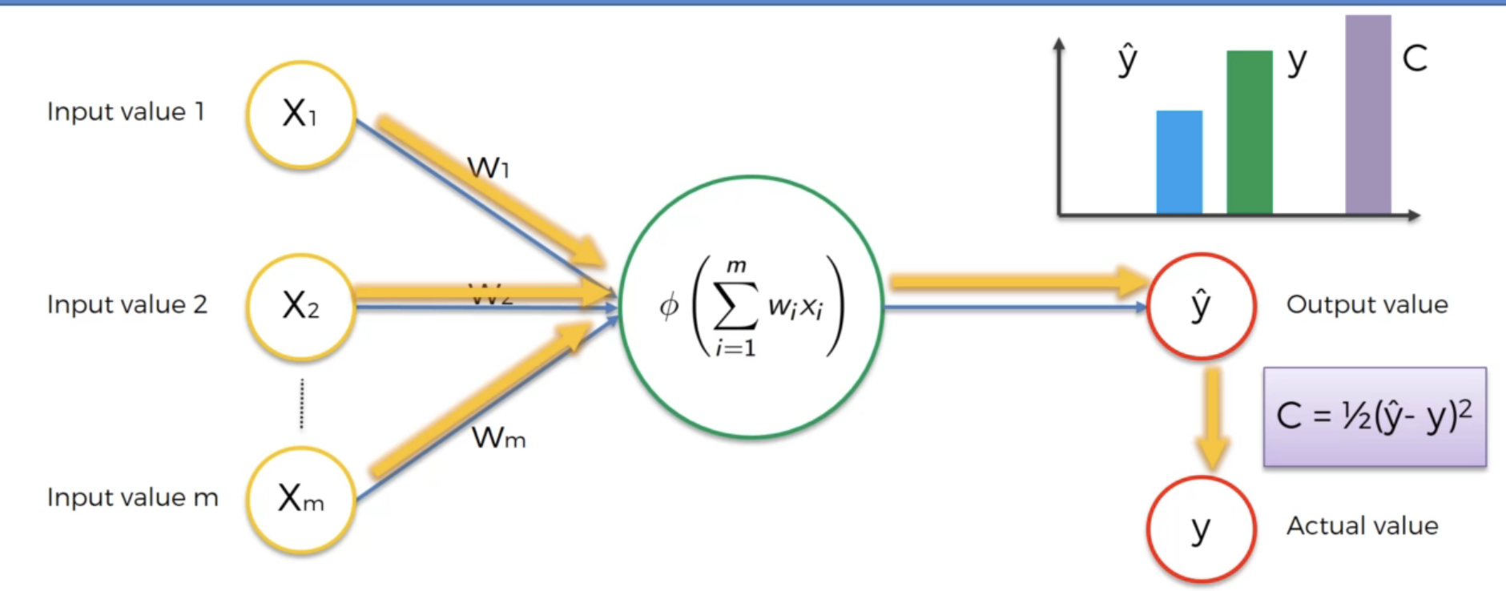

Feed the Cost / Error value back into the Neuron to update the Weight Values

So in total…

Feed the values 12 hours of studying, 6 hours of sleeping, past quiz score, the neuron calculates a predicted score, compare the score with the actual Score, then adjust the weights accordingly

Or you can do it in a big batch, calculate the Cost/Error after doing a bunch of predicting

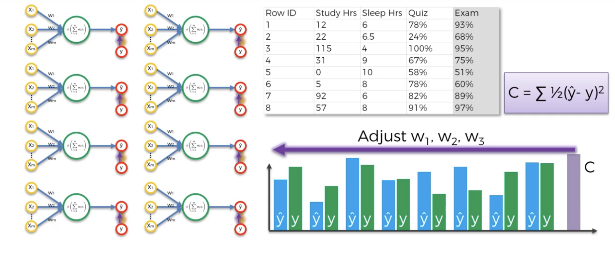

An Epoch in this context is one cycle of predicting and adjusting weights

This whole process is also called Backpropagation

a  
**Gradient Descent**  
How is weight adjusted?

Maybe you can use brute force, but that only really works when you have one input to change weights for, when you have multiple variables it’s harder to brute force it.

The Curse of Dimensionality, having multiple variables makes it more complicated

So you can’t just check 1,000 different values for 25 different weight variables

So Instead we use Gradient Descent

Check a few data points, and check the slope (positive or negative) and use it to help find the Best Weight, to minimize Cost/Error.

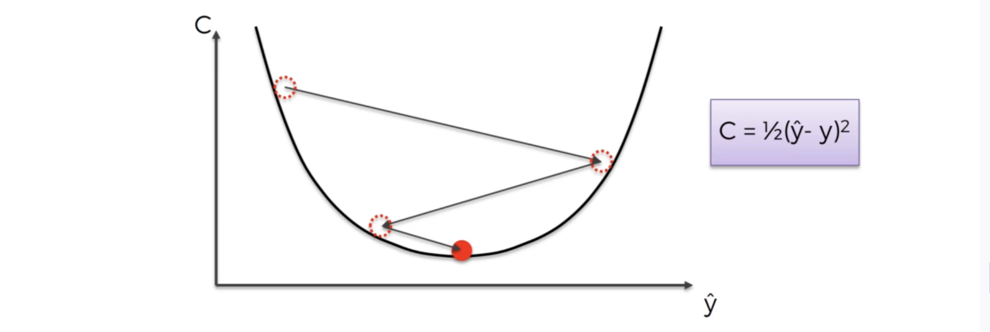

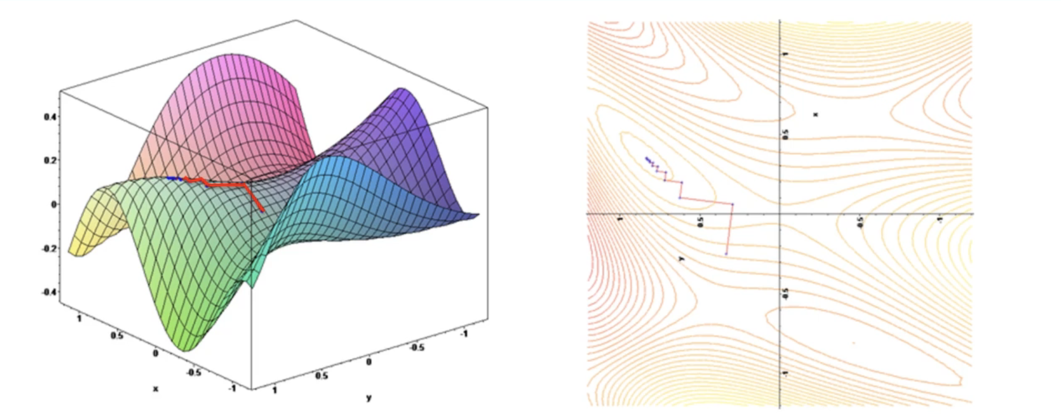

a  
**Stochastic Gradient Descent**  
Gradient Descent isn’t always so simple, especially if there’s multiple valleys (cause multiple variables)

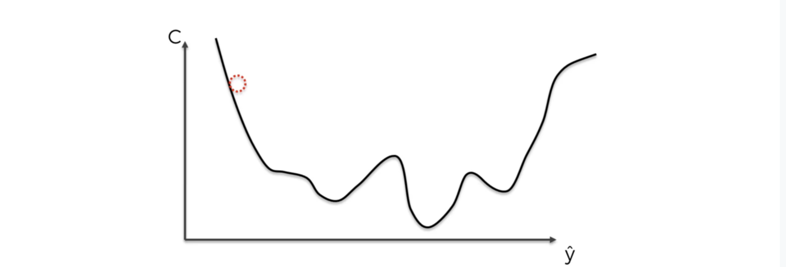

You might end up finding a Local minimum rather than overall minimum

Which is why you check the differences over the Entire table, not just one row. BATCH GRADIENT DESCENT it’s called

Stochastic Gradient Descent is a bit different where you Adjust the Weight every Row

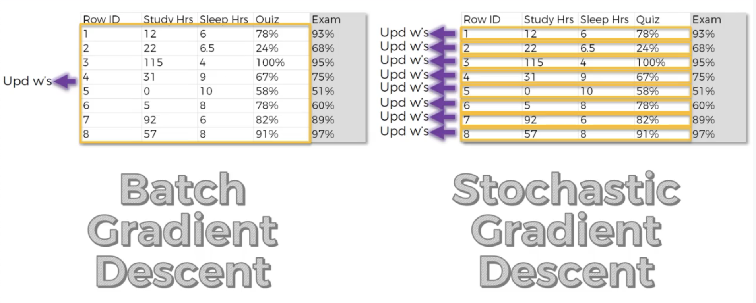SGD has more fluctuations which makes it more likely to find the global Minimum, Stochastic is also faster than Batch Gradient Descent.

The Main Benefit of Batch Gradient Descent is that it’s Deterministic rather than Random

You can also fuse both ideas to use “Mini-batch gradient” which is a combination of both

a  
**Backpropagation**  
Forward propagation is taking in the Input and predicting the Output

BackPropagation is taking the Error/Cost value and using it to adjust the weights of the NN

Another name for Stochastic Gradient Descent is “reinforcement Learning”

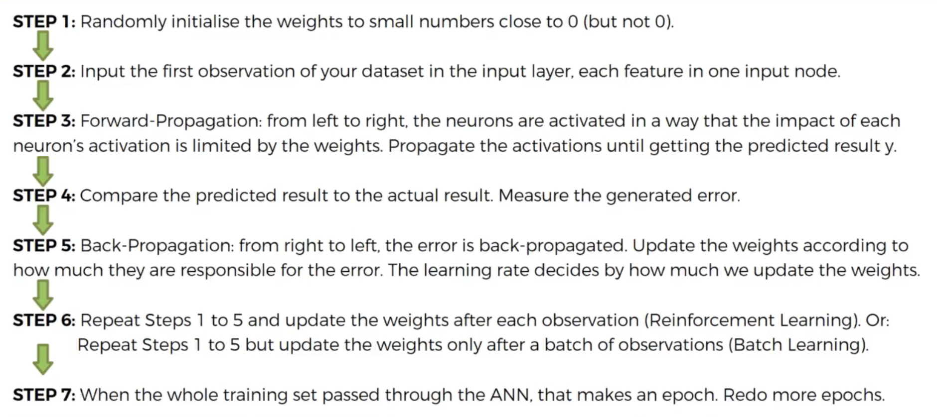

a

# Convolutional Neural Networks

Jjj

**What are convolutional Neural Networks?**

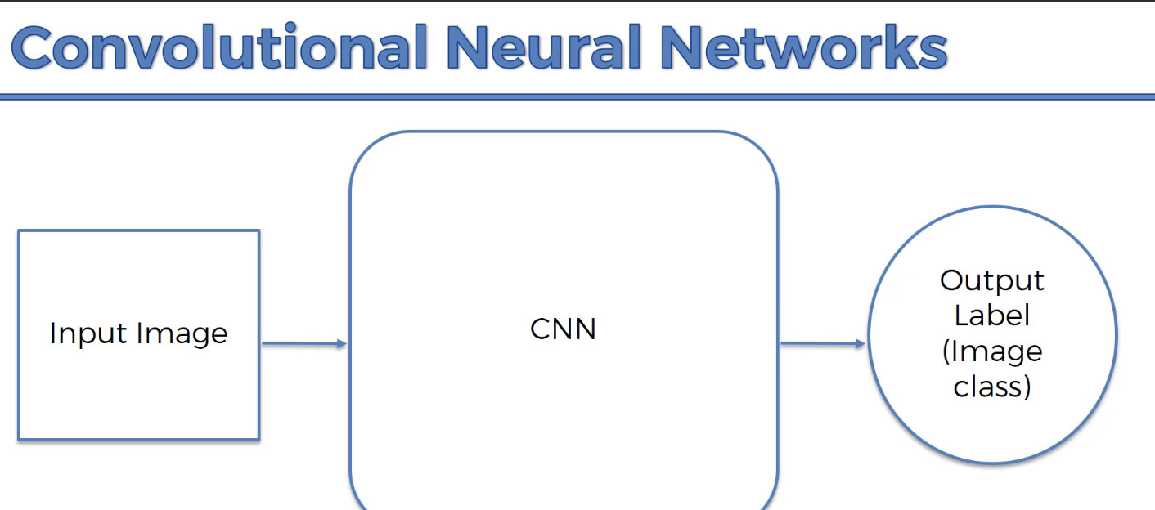

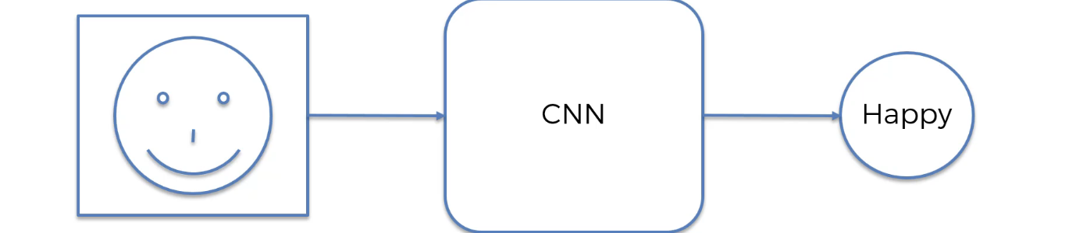

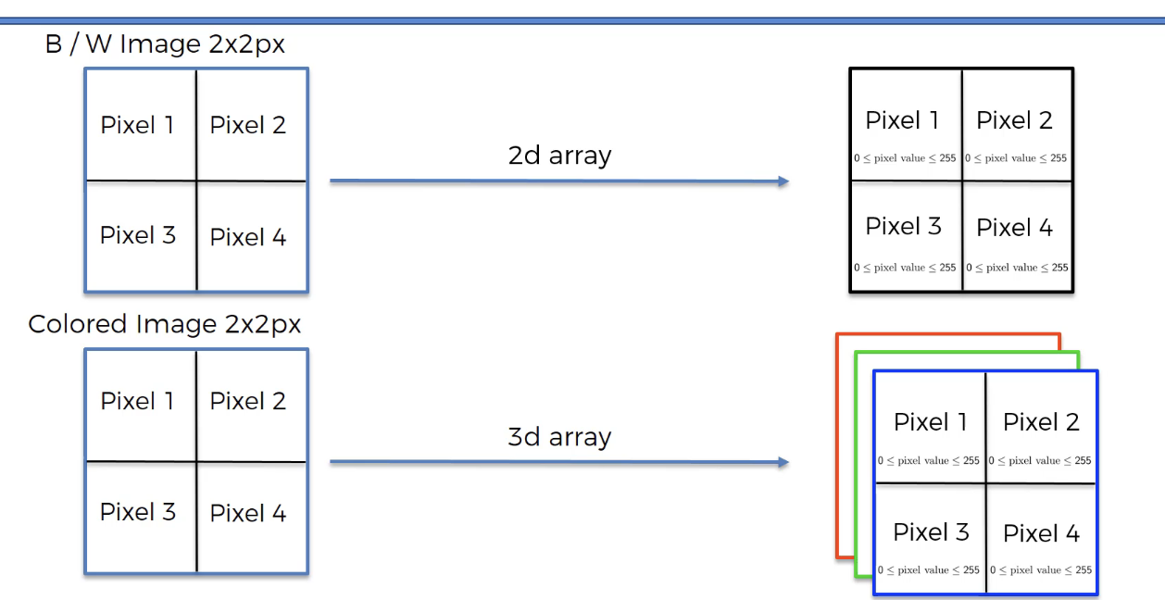

**Convolution Operation**

Convolution function 

One function modifies the shape of the other

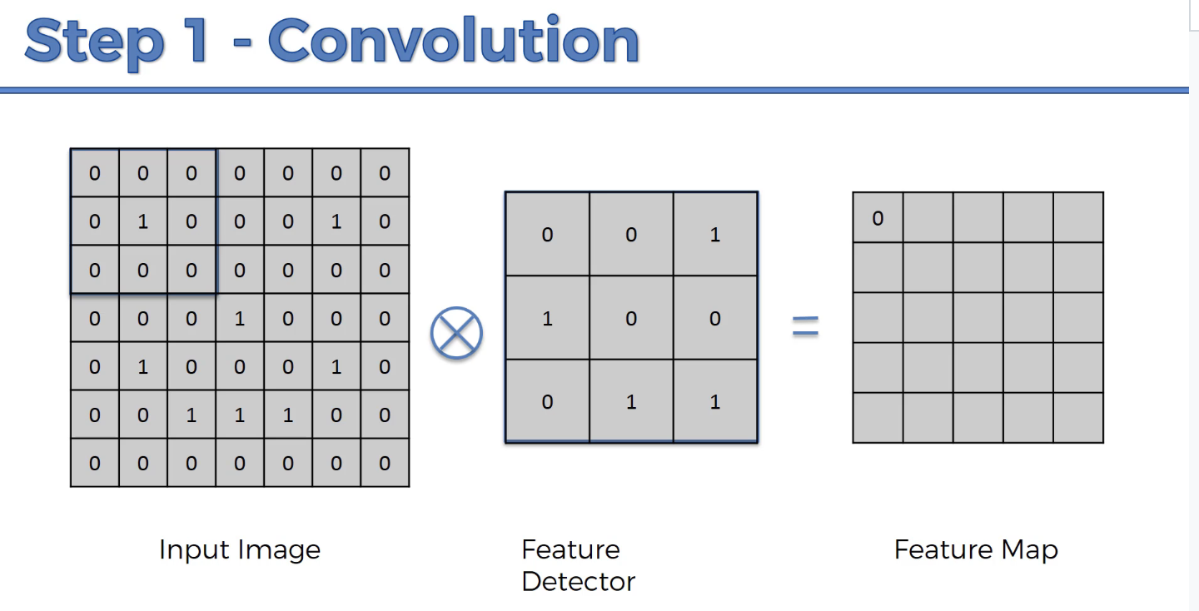

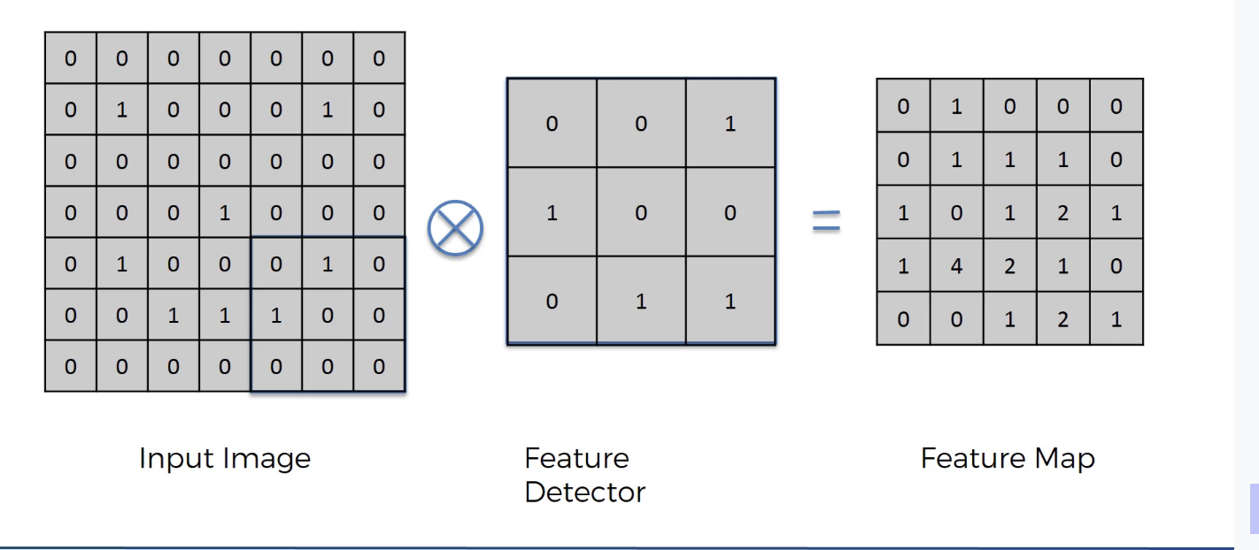

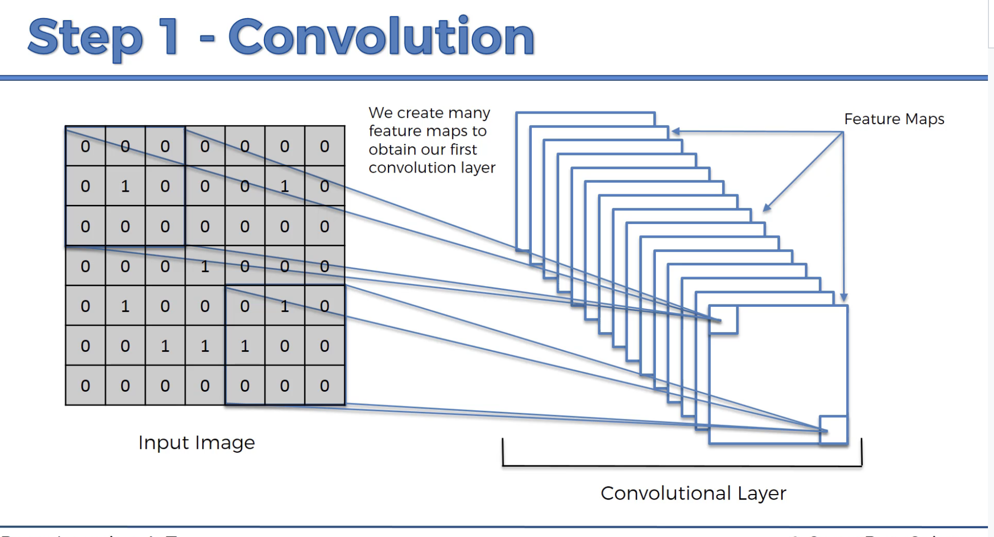

Gimp.org is a source for image training

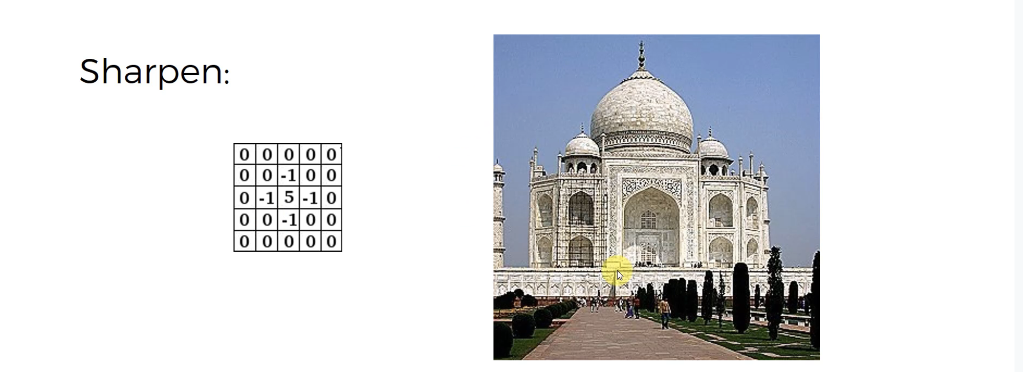

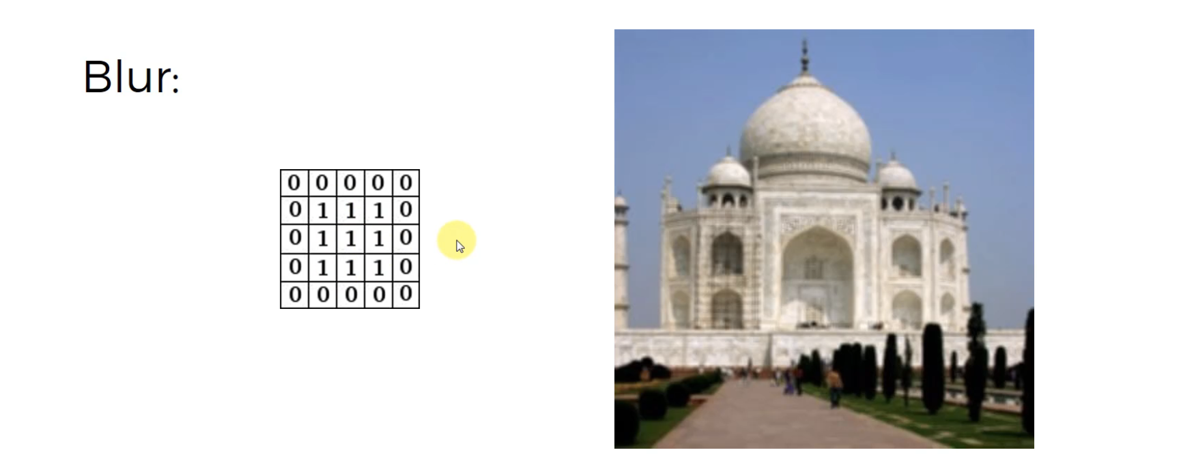

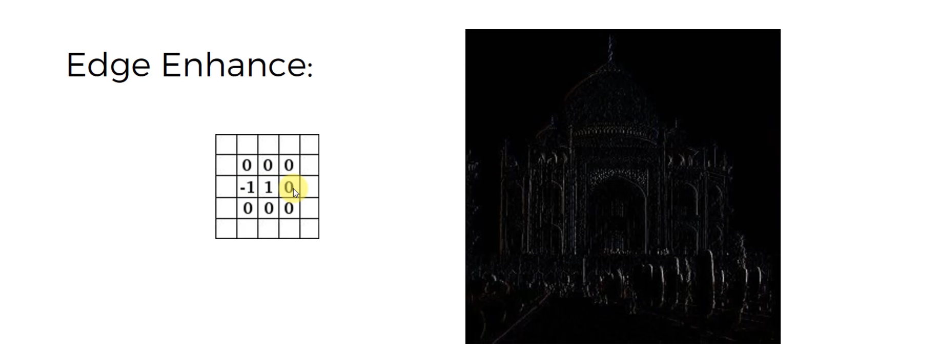

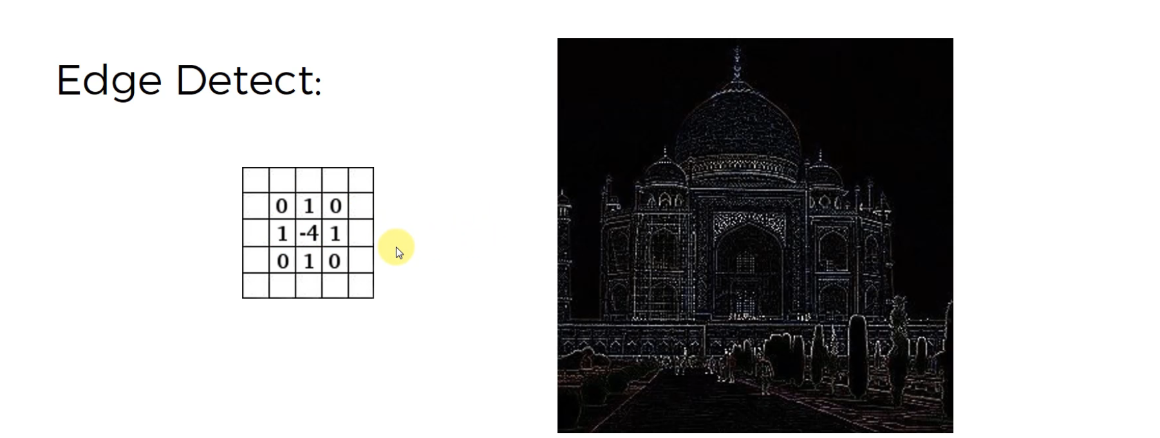

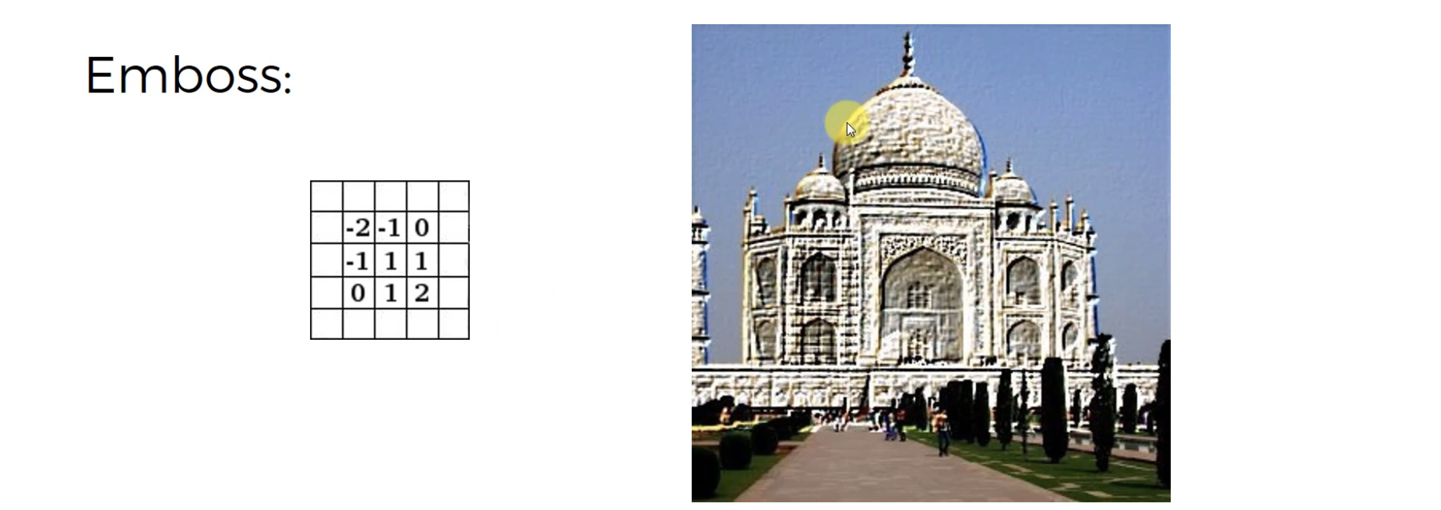

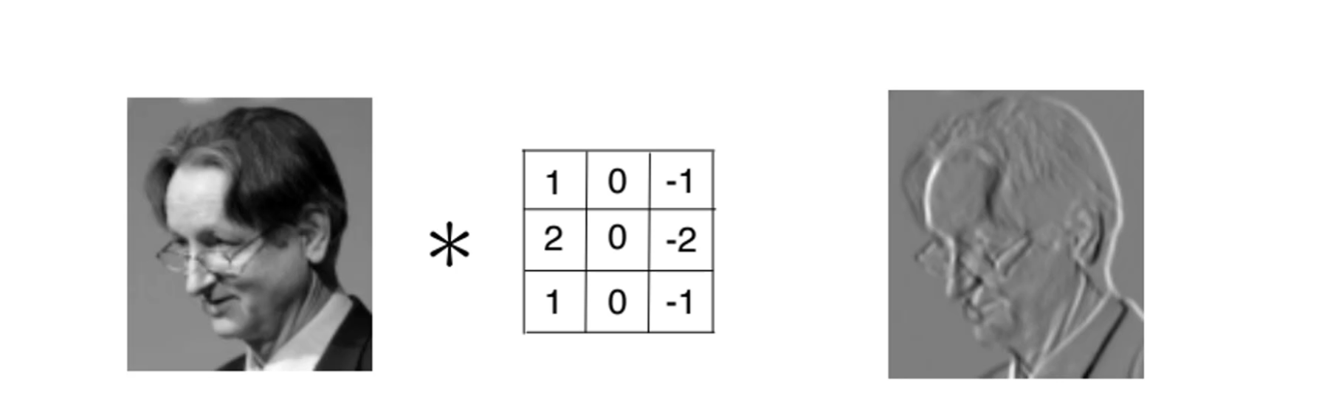

a

**ReLU Layer**

Aka Rectified Linear Units

Remember the Rectifier function?

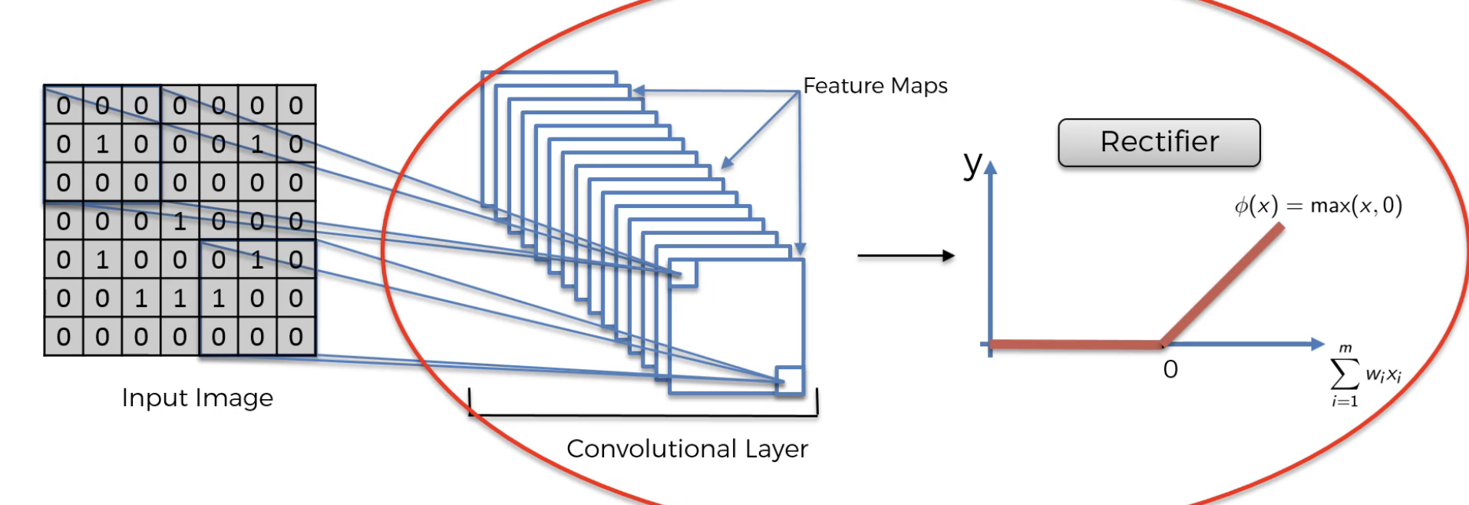

We use the rectifier function to increase non-linearity

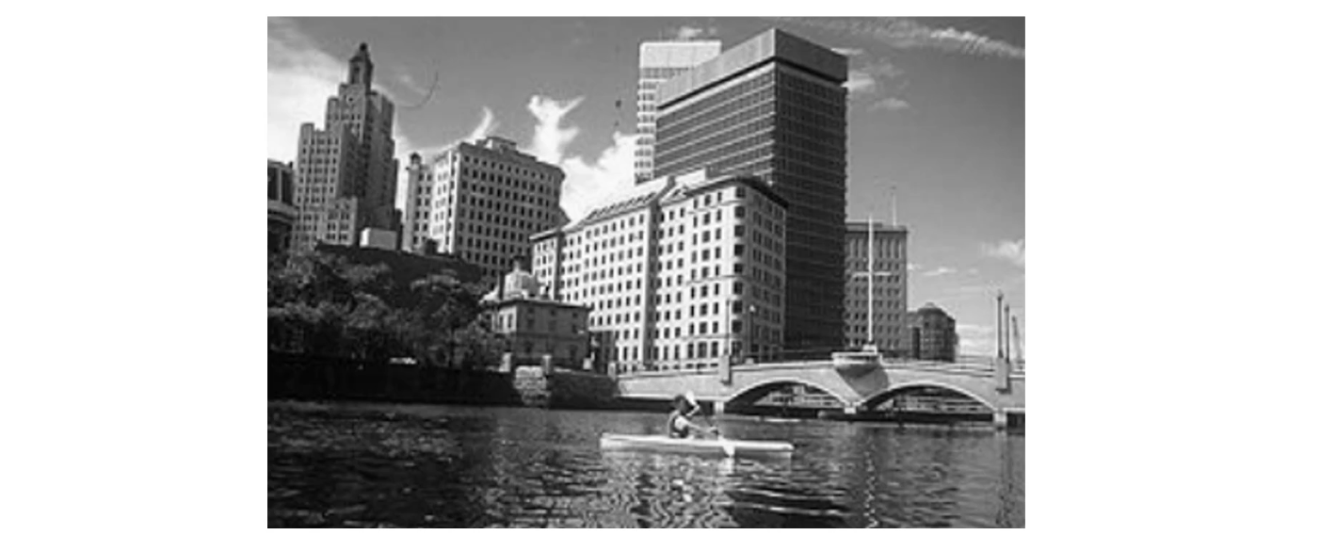

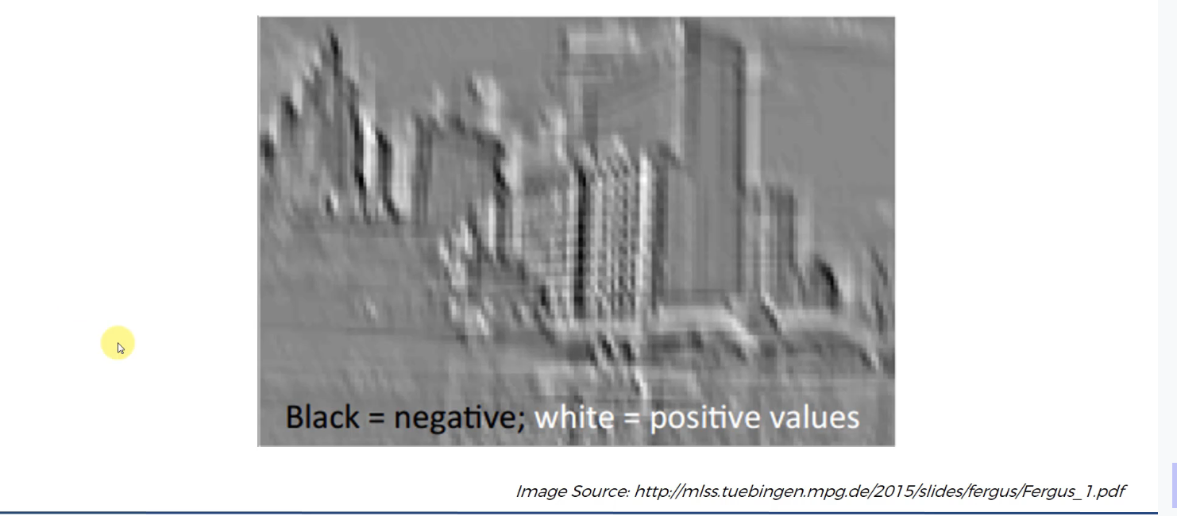

**Pooling**

Max Pooling specifically

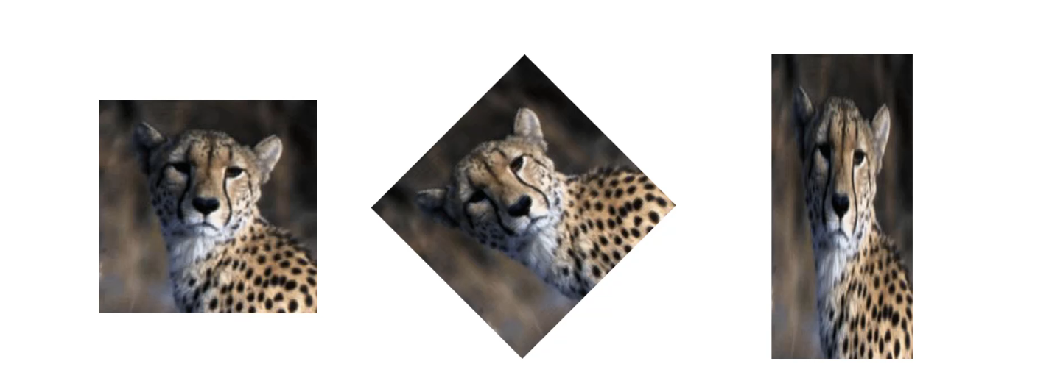

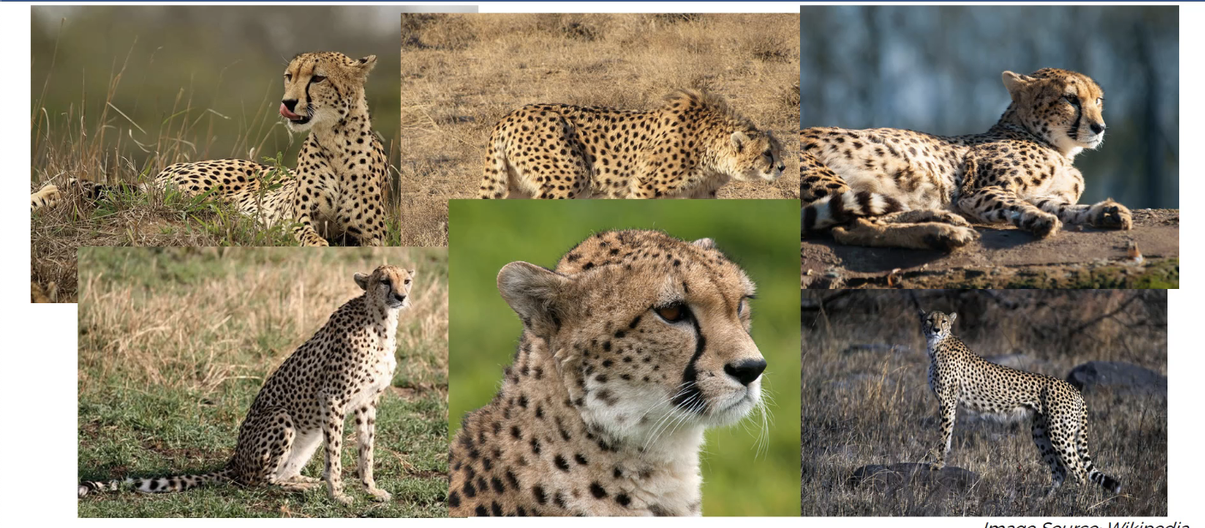

We want the neural network to recognize the cheetah in all these images

It’s called Spatial Invariance, so the neural network is more flexible to recognize features that are closer or further away.

Use a stride of 2, and the max pooling just gets the Max number in the square 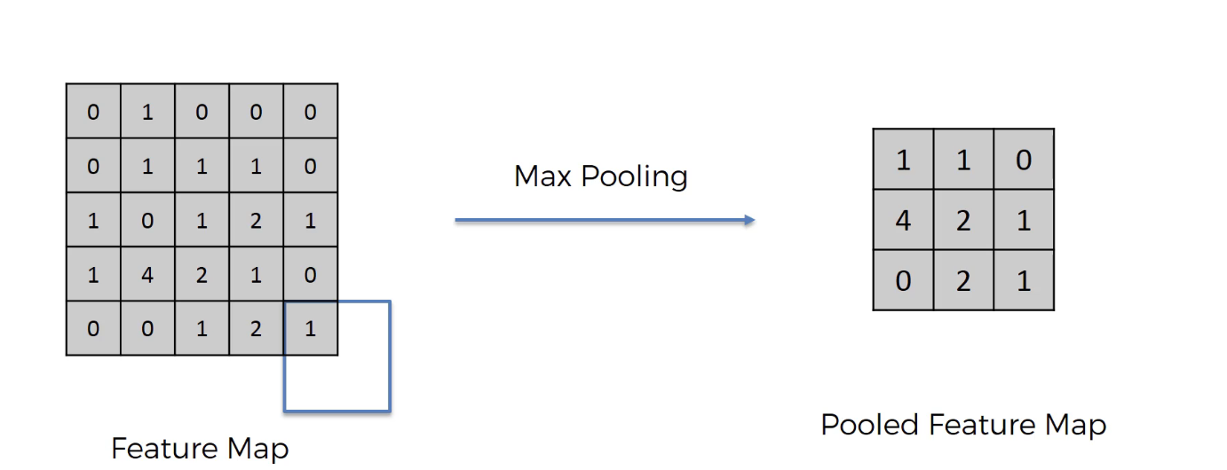

Scs.ryerson.ca is a cool tool

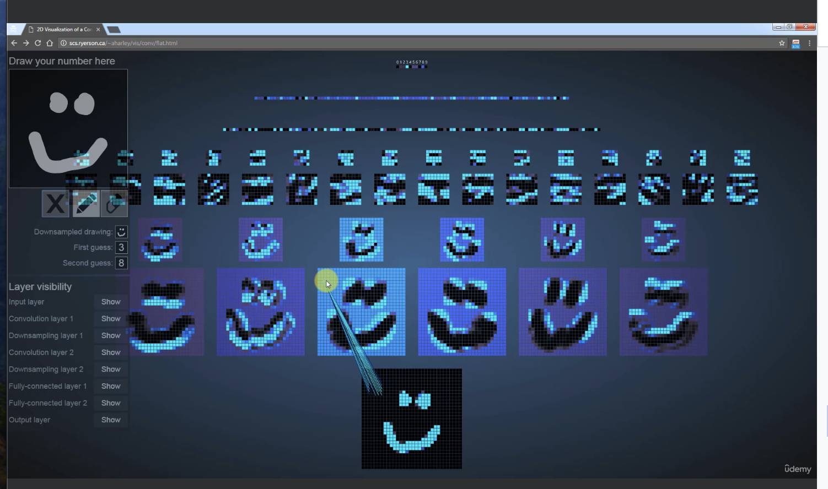

**Flattening**Full Connection

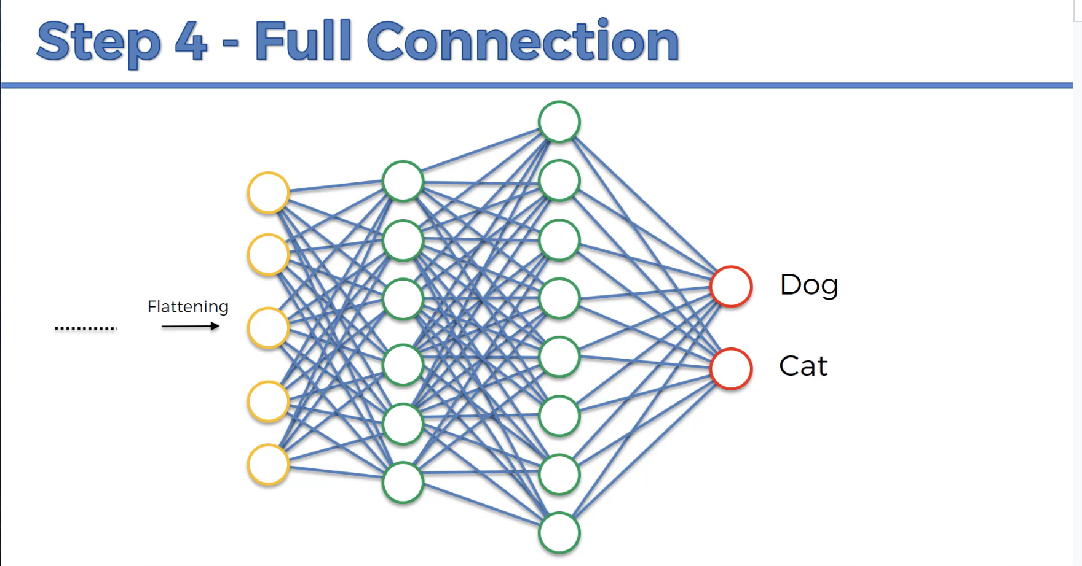

Go forward, and then take the loss factors to backpropagate to change the weights of each connection/neuron

**Summary:**

We started with an **input image**

to which we applied multiple **different feature detectors**,

or also called **filters**, to create these feature maps,

and this comprises our **convolution layer.**

Then on top of that conventional layer we applied the **RELU**

or **Rectified Linear Unit** to remove any linearity

or increased non-linearity in our images.

Then we applied a **pooling layer to our convolution layer**,

so from every single feature map

**we created a pooled feature map**.

And basically the pooling layer has lots of advantages,

the main purpose of the pooling layer

is to make sure that we have

a **special in variance in our images**,

so basically if something tilts or twists

or is a bit different to the ideal scenario,

then **we can still pick up that feature**.

Plus, pooling significantly **reduces the size of our images**

and also pooling helps with avoiding

any kind of overfitting of our data or of our model to the data,

because it just simply gets rid of a lot of that data.

But at the same time **pooling preserves the main features**

that we were after, just because the way it's structured

and the pooling we used was max pooling.

Then we **flattened all of the pooled images**

into one long a vector or column of all of these values

and we input that into an artificial neural network,

and that was step three flattening

and **step four is the fully connected**

artificial neural network

where all of these features are processed

through the network.

And then we have this final layer,

**final fully connected layer, which performs the voting**

towards the classes that we're after.

And then all of this is trained

through a forward propagation and back propagation process,

and lots of lots of iterations and (indistinct)

and in the end we have a very well defined neural network.

And another important thing is

**not only the weights are trained in artificial neural network part**

**but also the feature detectors are trained and adjusted in that same gradient decent process,**

**Softmax & Cross-Entropy**

A

You Can use the softmax volume to set the probabilities with logistic vectors

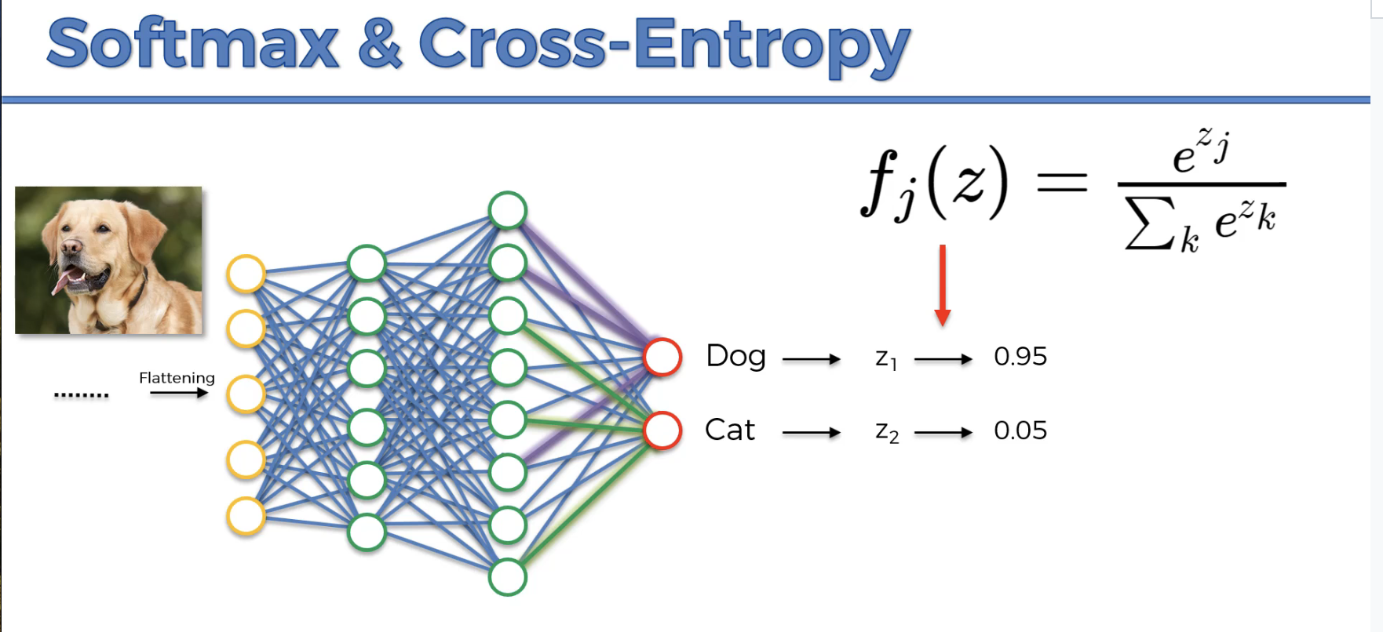

This is cross-entropy 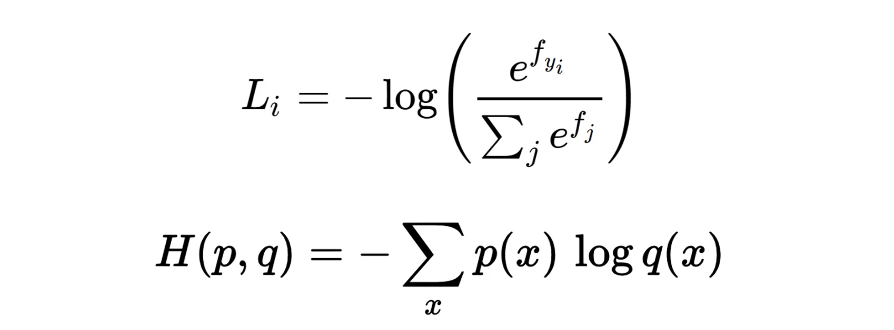

Mean Squared Error function, which we used as the cost function

for assessing our network performance.

And our goal was to minimize the MSE

in order to optimize our network performance.

Well, that was our cross function then.

The cost function is also called the loss function

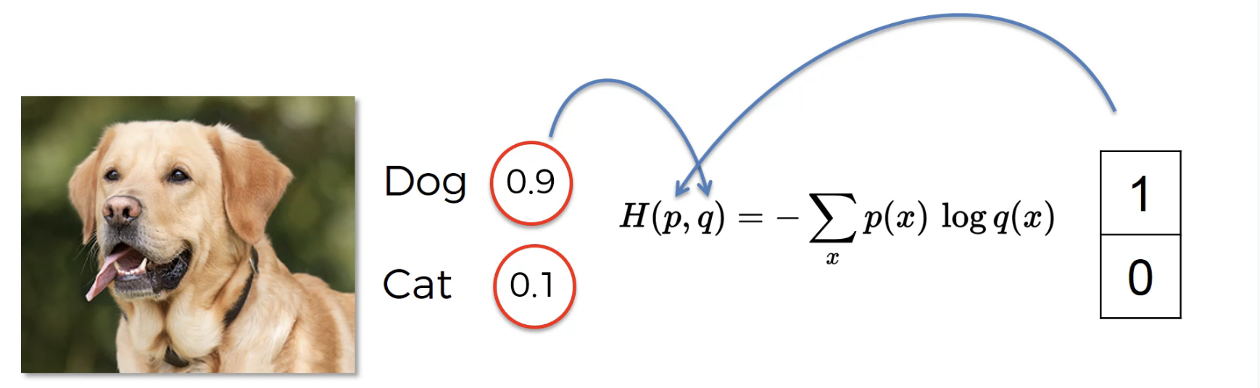

A

Classification Error - did you classify them correctly or not

Mean Squared Error - Average of the squared errors across observations

Cross Entropy - the formula is up above

Benefits of Cross Entropy over Mean Squared Error Involves

The backpropagation’s tiny output, and the gradient descent being low and slow. So Cross Entropy has logarithm in there which helps the network assess a small error quickly.

Cross Entropy also understands relative improvement even if numerically it’s still small

So if you're talking about things like **regression**

like which we had in artificial neural networks

then you would rather go with **mean squared error.**

Whereas **Cross Entropy is better for classification.**

And again, it has to do with the fact

that we're using Softmax function.

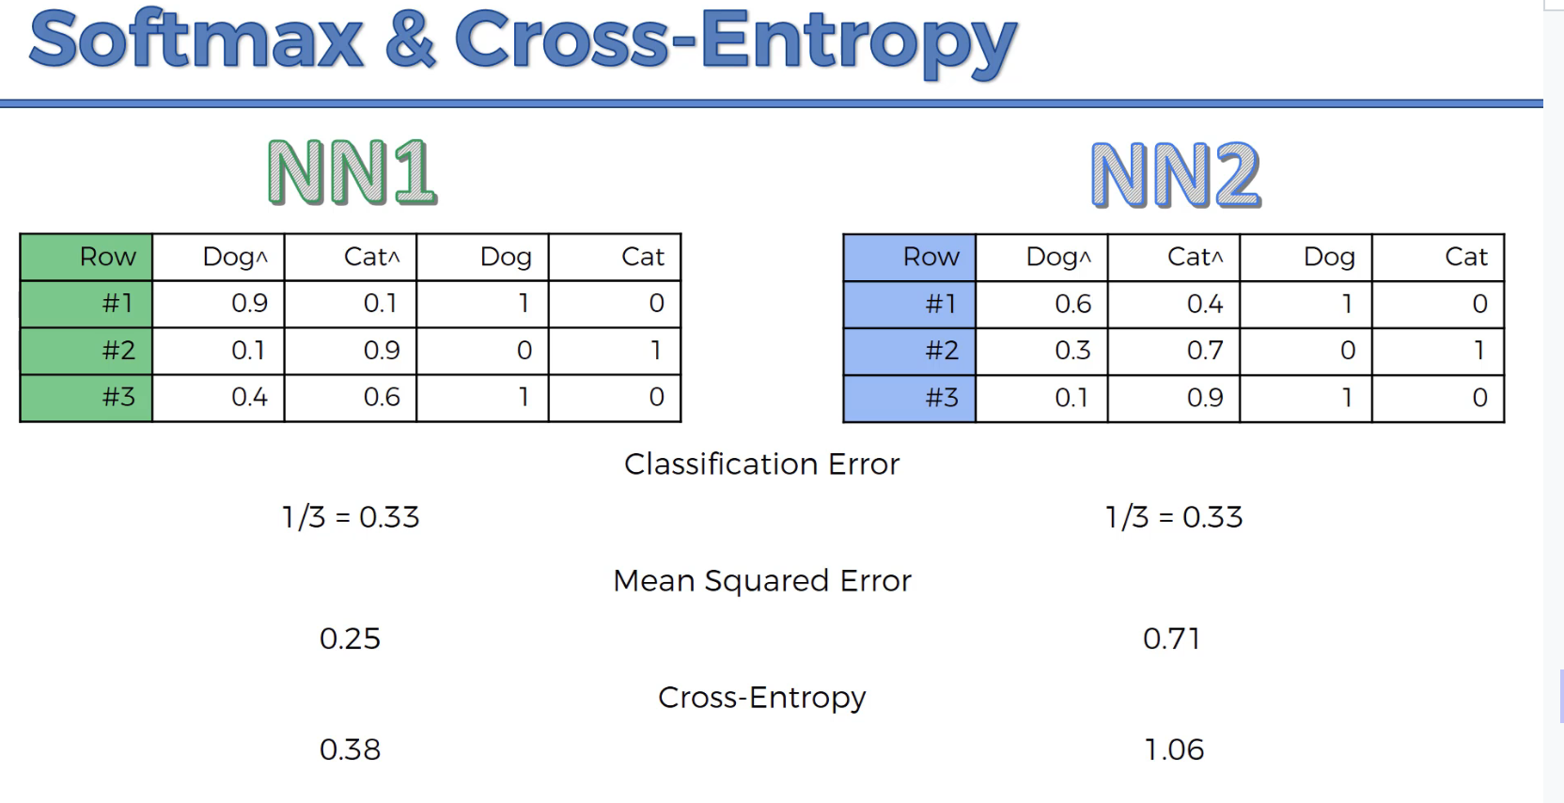

# Practice CoLab

<https://colab.research.google.com/drive/1S6Uu0T4gsbYMzXVUmJA9xyqz1Bio24AI>

A

Delivering letters in the city

# Convenience 1

Jjj

# Convenience 1

Jjj

# Convenience 1

Jjj